**JEFFERSON COUNTY DEPARTMENT OF EMERGENCY SERVICES**

**LOCAL EMERGENCY MANAGEMENT COORDINATORS**

**HANDBOOK**

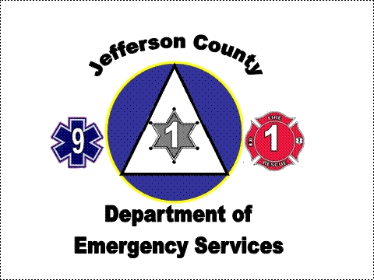



**April 1, 2024**

**Updated:**

## Preface

The Jefferson County Local Emergency Management Coordinator’s Handbook is designed for use by local Emergency Management Coordinators as a quick-reference for developing their emergency management program, and as an orientation tool for new coordinators. The information contained within was accurate at the time of publishing. For the most up to date information, visit the Jefferson County Department of Emergency Services website at <https://www.jeffersoncountypa.com>. Corrections or additions should be sent to Jefferson County Department of Emergency Service, 560 Service Center Road, Brookville Pa 15825. Special thanks to the York County and Indiana County for their assistance in developing this handbook.

Welcome to the world of Emergency Management! Your position in your community is a very important one as you are the liaison between your elected officials, your first responders, and community members. While this position in our rural setting is an important one for the safety and well being of those that reside or visit your area, it should not be a complicated effort. The biggest challenge you will face will be the development of your plan and making sure it is kept up to date so when a disaster strikes, you have all the information at your fingertips.

When the winds blow, and the water rises, and roads are closed because of flooding, tornados, winter storm events, etc., just remember these four words – “You are not alone!” You will have the support from friends and family, elected officials, County EMA staff as well as many different first responder outlets. They are there to help. All they need is you. They will provide you with whatever support you request.

On behalf of the Jefferson County Department of Emergency Services, I extend my congratulations in your new position and wish you the very best. My staff and I are only a phone call away to support your program and provide what assistance we can.

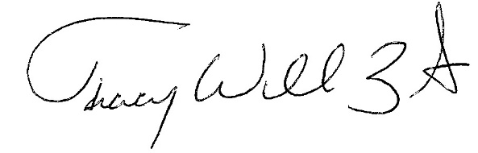

Director of Emergency Services

Jefferson County, PA

## Contents

|  |  |
| --- | --- |
| Section 1: What is Jefferson County DES? ……………………………………………………..……………… | 1-1 |
| Section 2: What is Emergency Management? ……………………………………………………………….. | 2-1 |
| Section 3: What is an Emergency? …………………………………………………….….………………………. | 3-1 |
| Section 4: Five Phases of Emergency Management ………………….…………….……………………. | 4-1 |
| Section 5: All Disasters are Local …………………………………………………….…….………………………. | 5-1 |
| Section 6: Media and Emergency Management ………………………………….….….…………………. | 6-1 |
| Section 7: Training and Exercises ……………………………………………………....…………………………. | 7-1 |
| Section 8: Community Emergency Response Teams ………..….…………….……………….………… | 8-1 |
| Section 9: Voluntary Organizations Active in Disaster …….…………………..………………………… | 9-1 |
| Section 10: The National Incident Management System …………………….…………….…………… | 10-1 |
| Section 11: Critical Incident Stress Management …………………………………………………………… | 11-1 |
| Section 12: Grant Management ……………………………………………….…………………….…………….. | 12-1 |
| Section 13: PEMA Emergency Management Certification Program.…………….………………. | 13-1 |
| Section 14: Emergency Manager’s Toolkit …………………………………………………….………………. | 14-1 |
| Section 15: Preparedness Toolkit …………………………………………….…..………………..……………… | 15-1 |
| Preparedness Checklist ……………………………………………………….……………………………………… | 15-3 |
| Sample Hazard Identification Survey ………………………………………………………………………….. | 15-5 |
| The Local Emergency Operations Plan ………………………………….……………………………………. | 15-7 |
| Sample Intergovernmental Cooperation Agreement ……………………….…………………………. | 15-10 |
| Working with the County Coordinator ………………………………………….………………………….. | 15-12 |
| Section 16: Response Toolkit ………………………………………………….…………….…….………………… | 16-1 |
| Response Checklist …………………………………………………………………………………………………….. | 16-3 |

|  |  |
| --- | --- |
| Notifying the EMA Duty Officer in an Emergency ……………………………………………………….. | 16-5 |
| When a Local EMC will be Notified of an Incident ………………………………………………………. | 16-6 |
| Declaring a Local Emergency ………………………………………………………………………………………. | 16-7 |
| Sample Declaration ……………………………………………………………………………………………………. | 16-9 |
| Submitting a Local Situation Report ……………………………………………………………………………. | 16-10 |
| ICS 209 Situation Report …………………………………………………………………………………………….. | 16-11 |
| Submitting an Initial Damage Assessment Report ……………………….…………………………….. | 16-13 |
| Section 17: Recovery Toolkit …………………………………………………………………………………………. | 17-1 |
| Recovery Checklist ……………………………………………………………………………………………………… | 17-3 |
| Stafford Act Declaration Process ………………………………………………………………………………… | 17-5 |
| Jefferson County Damage Form 1..………………………………………………………………………………. | 17-13 |
| Impact Statement ………………………………………………………………………………………………………. | 17-19 |
| Section 18: Mitigation Toolkit ………………………………………………………….……..…………………….. | 18-1 |
| Section 19: Media Toolkit ………………………………………………………………….……..…………………… | 19-1 |
| Media Checklist ………………………………………………………………………………………………………….. | 19-3 |
| Public Information Officer Assistance …………………………………………………………………………. | 19-4 |
| News Releases ……………………………………………………………………………………………………………. | 19-4 |
| Emergency Public Information Checklist …………………………………………………………………….. | 19-6 |
| Media Interview Tips ………………………………………………………………………………………………….. | 19-9 |

**What is Jefferson County DES?**

Disasters are going to happen despite our best efforts. Knowing how to deal with them helps to reduce loss of life and property now and in the future.

The Jefferson County Department of Emergency Services (DES), administers the Emergency Management Program (EMP). This program is a County-wide system that provides for management and coordination of prevention, mitigation, preparedness, response, and recovery activities for all hazards. The system encompasses all organizations, agencies, departments, and individuals having responsibilities for these activities. Jefferson County DES is led by the Emergency Management Coordinator (EMC) appointed by the Governor based upon the recommendation of the County Commissioners. The coordinator is an employee of the county and is responsible for implementing the program.

### Jefferson County DES Vision

It is the vision of the Jefferson County Department of Emergency Services to be recognized as the most professional, well respected, proactive, community and customer oriented municipal emergency management agency in the Commonwealth of Pennsylvania.

### Jefferson County Mission

Jefferson County Department of Emergency Services is charged with protecting the community by coordinating and integrating all activities necessary to build, sustain and improve the capability to prevent, mitigate, prepare for, respond to, and recover from threatened or actual natural disasters, acts of terrorism or other man-made disaster.

We undertake this mission with clear customer-focus and recognition that people are the most valuable asset. We value the contributions and dedication of the personnel who staff the emergency response and management systems. We employ and deploy the best available technologies in support of our mission.

1-1

## What is Emergency Management?

Emergency management is the process of preventing, preparing for, mitigating, responding to and recovering from a disaster or an emergency.

Emergency management is a dynamic process. Planning, though critical, is not the only

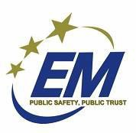component. Training, conducting exercises, testing equipment and coordinating activities with the community are other important functions.

Emergency Management is a legal responsibility and function of local, county, state, and federal government.

Federal and state laws were amended to include natural, technological, and man-made disaster prevention, mitigation, preparedness, response, and recovery programs. National attention to emergency management began in the early 1950s

with emphasis on civil defense or enemy attack preparedness.

Pennsylvania’s Emergency Management Services Code (35 Pa. C. S. Section 7101-7707) became law in 1978 and replaced the State Council of Civil Defense Act of 1951. The 1978 Act consolidated existing state laws and updated the role of emergency management within the Commonwealth. Amendments to this Act in 1988 and 1989 further focused the role of emergency management personnel, organizations, and responsibilities. It directs and authorizes every political subdivision (i.e., county, city, borough, incorporated town, and township) to have an emergency management program that includes a trained Emergency Management Coordinator (EMC), an Emergency Operations Plan (EOP), and a functioning Emergency Operations Center (EOC) with a trained staff.

This state law requires that every county and municipal government develop and maintain an emergency management program consistent with the state and federal emergency management program.

The Jefferson County Department of Emergency Services is authorized to administer the program on behalf of the County of Jefferson. The County EMC is authorized to develop and execute the program. The Jefferson County Board of Commissioners, charges the County Emergency Management Coordinator (EMC) to develop the County EOP and coordinate the preparation of supporting standard operating checklists.

2-1

Jefferson County DES is headquartered at the Emergency Services Building, located at 560 Service Center Road, Pine Creek Township. It is organized with a Director, Deputy Director/9-1-1 Coordinator, Deputy Director/Planning, and an Administrative Assistant. The staff is supplemented with a highly professional 9-1-1 staff and with a cadre of volunteers who support the Emergency Operations Center. See Section 21 for a more detailed look at Jefferson County Emergency Management Agency.



## What is an Emergency?

Jefferson County's geographical diversity, from hills to valleys, rivers and streams means that the County is open to a variety of natural disasters, ranging from severe thunderstorms to winter storms, from flash floods to droughts.

In addition, we must prepare for manmade threats, such as hazmat incidents and terrorist incidents.

The table below identifies the hazards mostly likely to affect Jefferson County and their associated risks (based on the 2023 Hazard Mitigation Plan). For more detailed information, see Jefferson County Hazard Mitigation Plan, Chapter 4 Risk Assessment.

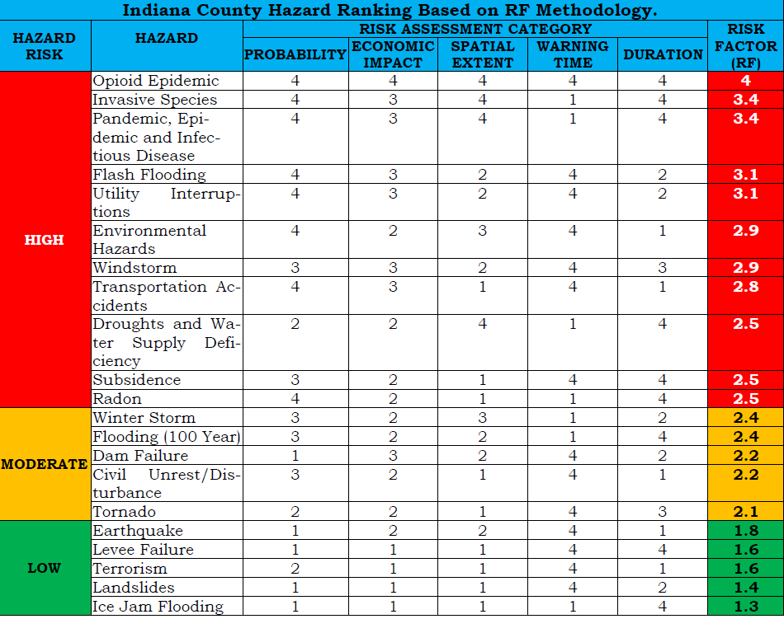

Some hazards are more likely to occur in some regions more than others so it is important for each locality to assess the risk of each hazard to its own jurisdiction.

See the Preparedness Toolkit for the Hazard Identification Survey.

3-1

## Five Mission Areas of Emergency Management

Disasters are going to happen despite our best efforts. Knowing how to deal with them helps to reduce loss of life and property now and in the future. Emergency Management can be divided into five missions.

### Prevention

Prevention happens when property and lives are protected by those that identify, deter, or stop an incident from occurring. Activities that may include these types of countermeasures can include:

* Heightened Inspections
* Improved surveillance and security operations
* Investigations to determine the full nature and source of the threat
* Public health surveillance and testing processes
* Immunizations
* Isolation or quarantine
* Law enforcement operations aimed at deterring, preempting, interdicting, or disrupting illegal activity

### Preparedness (Protection)

Planning and training are keys to effectively dealing with different types of disasters. Emergency plans are developed as blueprints for response to a variety of scenarios and assist communities in developing localized emergency operations plans.

Jefferson County EMA prepares and maintains the Emergency Operations Plan (EOP) for the county. The EOP describes the hazards, vulnerabilities, emergency management situations, and assumptions that affect the county, the concept of operations during an emergency, and the various roles and assignments of the elected officials, EMC, and other emergency response personnel, whether paid or volunteer. The county EOP is consistent with NIMS and the Pennsylvania State EOP.

4-1

The local EMC is responsible for preparing and maintaining the municipal EOP at the local level. See the PEMA website for a planning guide and sample plan.

Jefferson County EMA works with the Local Emergency Planning Committee (LEPC) to prepare the Facility Off-site response plan for SARA facilities.

Jefferson County EMA also coordinates and works with local nursing homes, assisted living facilities, schools, daycares, and dams to ensure their plans are current.

Jefferson County EMA offers training four times a year through the Local EMC Quarterly Training Program. The training program will be consistent with the PEMA requirements for EMCs. The EMA will also provide additional training in emergency management. These training, and other training offerings, are typically shared via email to municipal EMC’s and Local Elected Officials.

Preparedness training and exercises are a comprehensive way to achieve full and sustainable performance by key leaders, emergency responders and citizens in response to emergencies and disasters involving:

* planning,
* organizational,
* operational, and
* technical measures

The goal of training and exercise programs is to achieve a standard of performance from the individual to the organizational level that is repeatable.

That standard may define first time skills or sustain proficiency in previously acquired skills. Regardless, each of those standards must be framed in the context of real-world operations.

We must train as we intend to function in putting those skills to use.

The Pennsylvania Emergency Management Agency (PEMA) offers training courses in emergency management, hazardous materials response and search and rescue to prepare local responders to effectively deal with disasters and their aftermath. Exercises and drills conducted across the Commonwealth offer opportunities to put these skills into practice in a controlled setting.

4-2

### Response

When citizens face an emergency, they call 9-1-1. When local governments need assistance in responding to a crisis, they call Jefferson County EMA. The county coordinates with other municipalities as well as the Northwest Central Regional Task Force (Region 3) to provide resources needed to handle a disaster. The county may activate the EOC to help coordinate the response. If needed, the County will turn to the Commonwealth, through PEMA, to coordinate response efforts. If warranted, the Governor will declare a disaster emergency and ask for assistance through the Federal Emergency Management Agency (FEMA). The President of the United States may issue a disaster declaration that clears the way for federal disaster assistance.

### Recovery

After disaster strikes, citizens are anxious to return to their normal lives as quickly as possible. Under a federal declaration, victims should contact FEMA to register for disaster assistance.

Several basic state and federal financial aid programs may be available to displaced residents in these areas. Jefferson County EMA staff works with PEMA and FEMA to coordinate and administer these programs. In most instances, the federal government pays 75 percent of the cost, and the state and localities cover the 25 percent non-federal share.

Jefferson County EMA is partnered with various County Volunteer Agencies Active in Disaster (VOAD) that offers a wide variety of services.

### Mitigation

Emergency management goes beyond helping communities recover from a disaster. Preventive measures now can help mitigate or lessen future losses. Many repairs can incorporate steps that will reduce or eliminate potential damage.

Jefferson County DES works with local municipalities to assist them in designing effective, all- hazard mitigation plans to address hazards specific to their communities. The Jefferson County Department of Emergency Services, in conjunction with EMA and the municipalities, has developed the Jefferson County Hazard Mitigation Plan.

4-3

## All Disasters Are Local

Local governments are the first line of defense against disasters and emergencies in their communities. They are primarily responsible for managing the response to emergencies and disasters.

Local governments are responsible for:

* Warning citizens,
* Containing the emergency,
* Protecting people and property, and
* Minimizing damage.

In accordance with Title 35, a municipal coordinator is appointed by the Governor upon the recommendation of the executive officer or governing body of the municipality. The coordinator shall be

professionally competent and capable of exerting leadership, planning, training, and effecting coordination among operating agencies of government and controlling coordinated operations. Without a doubt, the most important responsibility of municipal officials, and the municipal coordinator, is to coordinate disaster response in the first 24-72 hours after any emergency. The EMC has a major role to play in helping the community and residents achieve the proper level of preparedness, response, recovery, and mitigation activities for whatever may affect the municipality. The EMC must create interest, motivate, and involve the community in these activities and keep elected officials informed and involved with these preparations. Each EMC should use the resources available at the county and state level and within the community to assist with these responsibilities.

Before a disaster ever strikes, to ensure that a local government can meet the needs of its citizens, local EMCs should:

* Develop and maintain an Emergency Operations Plan, to include:
  + Basic Plan (reviewed every two years),
  + Functional Checklists (reviewed every two years), and
  + Notification and Resource Manual (reviewed every year and updated every 90 days)
* Exercise this plan to identify and fix any shortcomings,
* Identify hazards and vulnerabilities that may affect the municipality,
* Participate in the County Hazard Mitigation Team and assist in pre-disaster mitigation planning and grant submission efforts,
* Develop, maintain, and ensure certification of trained staff to work in the municipal EOC when activated and ensure they are Duly Enrolled,
* Compile cost figures for the conduct of emergency operations,
* Coordinate long-term recovery and mitigation efforts,
* Obtain important information on special needs residents living in their communities,
* Identify resources within the municipality that can be used to respond to a major disaster or emergency and request needed resources from the county EMA,
* Attend training, workshops and seminars provided by municipal, county, state, and other sources to maintain proficiency and currency in emergency management,
* Attain certification in accordance with PEMA Directive 2022-02 and Title 35,
* Participate in all tests, drills and exercises as scheduled by the county and Commonwealth,
* Maintain current plans, procedures, guidance, and laws issued by the county, PEMA, and the Commonwealth within the EOC,
* Have knowledge of the federal and state required plans for the jurisdiction and coordinates with all applicable agencies dealing with emergencies at dams, chemical and nuclear facilities, schools, daycares, hospitals, prisons, nursing home facilities and special events,
* Participate in the integrated flood warning systems program as applicable for the municipality,
* Develop mutual aid agreements, as applicable, with adjacent municipalities,
* Ensure the municipality is compliant with NIMS, and
* Perform other duties as assigned by the municipal elected officials. During a disaster, the local EMCs should:
* Provide immediate aid to its citizens through fire, police, medical and rescue,
* Mobilize the EOC and act as the Command function within the ICS structure,
* Respond to the location of a disaster as requested by municipal officials or the county EMC,
* Encourage and ensure municipal officials declare disaster emergencies when needed and submits the signed declaration to the county EMA,
* Ensure public order and security,
* Restore essential, vital services,
* Assist individuals and families in need,
* Assist those with special needs,
* Request help from the county when needed,
* Communicate emergency information to the public in a timely and accurate manner,
* Provide prompt, accurate information regarding disaster emergencies to the county EMA,
* Maintain coordination with the County EMA, and
* Conduct damage reporting and expeditiously (within 24 hours of a disaster) provide the information to the county EMA.

### Getting Started

There is a lot to do, so where do you begin? First thing is to make sure your municipality has submitted the appointment paperwork to Jefferson County EMA. See the PEMA website *www.pema.pa.gov › Documents › Municipal-EMC-Nomination-Form* for the appropriate paperwork. The next step is to submit your contact information to Jefferson County EMA. This paperwork can be obtained from Jefferson County EMA office.

Next, look at your municipality’s current Emergency Operations Plan. Is it updated? The Basic Plan should be updated every two years. If it needs updated, PEMA is utilizing the CEM planner to develop plans and store them for easy accessibility from any location. [CEM Planner (pa.gov)](https://www.pema.pa.gov/Preparedness/Planning/Community-Planning/Pages/CEM-Planner.aspx)

Look at your municipality’s Emergency Operations Center. Is it adequate for handling an emergency?

Make sure you have an adequate staff to conduct business. Make sure your staff is Duly Enrolled.

Finally, make sure you and your staff are trained and certified. Again, see the PEMA website for Training and Certification requirements. (A copy of the current PEMA Directive is attached.)

**Common Mistakes to Avoid:** Source: New Director’s Orientation Notebook, National Emergency Management Association.

A combination of field experience and research has identified the following common mistakes made in managing emergency operations. Each mistake is coupled with a suggested tactic for avoiding that mistake.

* Lack of a viable disaster plan.

Suggestion: Do your homework in planning. Planning provides the foundation and blueprint for all emergency response.

* No knowledge of disaster resources.

Suggestion: Know your resources. Be aware of all the resources that are available with specialized capabilities and limitations noted. Improper use and designation of resources ranks high as a major complication in disaster operations.

* Lack of visible leadership.

Suggestion: Ensure that somebody runs the show. The larger and more complicated a disaster becomes, the fewer the individuals who want to step forward and assume a leadership role. Establish the positions ahead of time during the planning process to provide viable leadership either through a committee or an individual.

* Bad decisions make the situation worse.

Suggestion: Do not make it worse. While this suggestion seems simple, logical, true, and obvious, it is hard to grasp its full significance under a crisis situation. Think about your decisions, get a good grip on the situation, and do not let people take foolish chances.

* Trying to obtain too much information, while neglecting the information flow.

Suggestion: Maintain control of the information flow. Reliable filters must be established to provide some isolation from all the input information clamoring for attention.

* + Establish a pattern for information flow, and frequently monitor how well the right information is getting to the right people.
  + Check for information reliability.
  + Create an efficient plan to pass on information to the outside world. (People outside the affected area need an overview of what is going on.)
* Focusing on the insignificant.

Suggestion: Prioritize the problems—do not be drawn into trivia. Plan which types of problems will need to be handled first. Keep your focus on important issues and refuse to deal with anything else.

* Unknown Emergency Operations Center staff.

Suggestion: Know the emergency staff before the disaster occurs. Test the staff through a competency exercise program, and learn their capabilities during a non-emergency time.

## Media and Emergency Management

Managing the media is a key component of any effective emergency management plan. It could well determine how your organization is viewed by customers, employees and of course the public. This could equally influence your chances of full recovery following an incident.

### Tips for dealing with the media in a disaster or emergency

1. Establish good relations with the local media—before a disaster or emergency.

By cultivating good relationships with the media prior to an emergency, you’ll get better support from the media during the hectic hours of responding to an emergency. You want to cultivate a situation where the media feels it can contribute a vital role during the response efforts. The media, when supportive, can convey important information to the public about such issues as evacuations and disaster-assistance information.

1. Responding to Questions.
   * Answer all questions as directly and completely as possible.
   * If you do not know the answer to a question, say so. Do not risk a guess. Erroneous information can damage your credibility and the public’s perceptions of your ability to tell the truth and convey accurate information. Ask the reporter to leave his or her name and telephone number so that you can provide an answer.
   * Do not exaggerate the facts. Give the facts as you know them and cite your own sources. In an emergency or disaster, the information you reveal could threaten lives if it is incorrect.
   * Tell the truth and avoid using “no comment.” No comment gives the impression that you have something to hide. Never give “off-the-record” information—it could come back to haunt you.
   * Never argue with reporters or lose your cool. Do not be rude even if the interviewer or reporter appears to doubt your credibility.
   * If you are interrupted, wait for the interrupter to finish and then proceed with your answer. You may wish to repeat the original question to bring the audience back on track.
   * Challenge any efforts to put words in your mouth. If you do not, you may end up appearing to agree with something you actually disagree with.
   * Do not act evasive. Your evasiveness may be interpreted as an attempt to hide something.
   * Be alert. Avoid answering speculative “what if” questions. Be prepared to lead the interview from problems and negatives to positive points you want to make.

6-1

1. Delivery of Your Message
   * Speak naturally.
   * Avoid using “jargon” or terminology that isn’t familiar to those working outside of emergency management.
   * Avoid long, rambling responses—be succinct and clear in your responses. Say the most important thing first, then elaborate if necessary. Make one point at a time. Speak in simple, rather than compound sentences.
   * If you must read a prepared statement, read in a relaxed manner—avoid stilted, halting speeches.
   * Be believable. Credibility is vital to getting your message across. Be personable and conversational.
2. During the early stages of an emergency or disaster, hold frequent briefings or press conferences. These briefings and conferences help to fill the information void that the media may experience during the early stages of the disaster and satisfies the media’s need to speak with an authority or official about the situation.
3. Establish a joint information center (JIC) during the early stages of the disaster response. Be sure to set up accommodations for the press (seating areas, phone lines, faxes, etc.). Identify the lines of responsibility in the JIC so all know their jobs and have a team management approach to handling the situation. There is no place in disaster management for personality disputes.
4. Appoint a public information officer (PIO) to deal with the media. The PIO then becomes a centralized voice for the event thus eliminating confusion and conflict about which source of information is correct, etc.
5. Be available and visible to the press as much as possible. If you plan to deny reporters’ access to the damage site, then be available to explain why and offer alternatives.
6. Institute an official “rumor control” plan. An effective mechanism is the use of a hot-line where persons can call to report a rumor and seek confirmation or disconfirmation.
7. Plan for good intergovernmental relations to present a clear picture to the press of who is in charge. You want to avoid presenting a scenario where different levels of government are “at odds” over who is governing the emergency or disaster.
8. After the disaster, consult with media personnel to find out what could have been done better—and act on it!

6-2

## Training and Exercises

Exercises allow homeland security and emergency management personnel, from first responders to senior officials, to:

* Train and practice prevention, protection, response, and recovery capabilities in a realistic but risk-free environment,
* Assess and improve performance, and
* Demonstrate community resolve to prepare for major incidents.

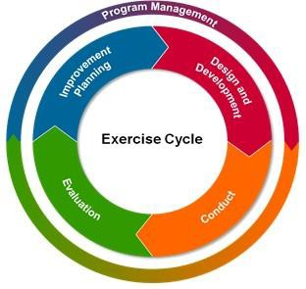Through exercises, EMCs obtain objective assessments of their capabilities so that gaps, deficiencies, and vulnerabilities are identified and remedied prior to a real incident.

[The Homeland Security Exercise and](https://www.fema.gov/media-library/assets/documents/32326) [Evaluation Program (HSEEP)](https://www.fema.gov/media-library/assets/documents/32326) is a capabilities- and performance-based exercise program.

The intent of HSEEP is to provide common exercise policy and program guidance capable of constituting a national standard for all exercises.

HSEEP includes consistent terminology that can be used by all exercise planners, regardless of the

nature and composition of their sponsoring agency or organization.

#### HSEEP Doctrine

An effective exercise program is an essential component of our national preparedness as it validates plans, tests operational capabilities, maintains leadership effectiveness, and examines ways we utilize the whole community. Exercise program management involves a collaborative approach that integrates resources, organizations, and individuals in order to identify and achieve program priorities.

Key factors drive the exercise design and development process. Exercise practitioners use the intent and guidance of their elected and appointed officials and the exercise program priorities to shape the key concepts and planning considerations for exercises. In designing and developing individual exercises, exercise planning team members are identified to schedule planning meetings, identify, and develop exercise objectives, design the scenario, create documentation, plan exercise conduct and evaluation, and coordinate logistics.

7-1

Exercise conduct involves activities essential to conducting exercises such as preparing for exercise play, managing exercise play, and conducting immediate exercise wrap-up activities. Throughout these efforts, the engagement of elected and appointed officials by practitioners will ensure that the exercise is addressing the guidance and intent of officials.

Exercise evaluation is the cornerstone of an exercise maintains the functional link between exercise and improvement planning. Through exercise evaluation, organizations assess the capabilities needed to accomplish a mission, function, or objective. Effective exercise evaluation involves planning for exercise evaluation, observing and collecting data during exercise conduct, analyzing data, and reporting exercise outcomes.

Exercises afford organizations the opportunity to evaluate capabilities and assess progress toward meeting capability targets in a controlled, low-risk setting. An effective corrective action program develops improvement plans that are dynamic documents, with corrective actions continually monitored and implemented as part of improving preparedness.

HSEEP reflects lessons learned and best practices of existing exercise programs, and can be adapted to a variety of scenarios and events (e.g., natural disasters, terrorism, technological disasters). HSEEP is compliant with, and complements, several historical and current Federal directives and initiatives. Some of these directives and policies include the following:

* National Strategy for Homeland Security
* HSPD-5, Management of Domestic Incidents
* HSPD-8, National Preparedness
* National Exercise Program (NEP)
* National Preparedness System
* NIMS

The following elements are part of the exercise methodology:

* A cycle of exercise activity that includes exercises of increasing levels of complexity (building-block approach, Figure 1 below);
* Threat-based, realistic, and accurate exercise scenarios;
* Exercises that involve players from multiple disciplines to test interagency relationships and agreements;
* A means of evaluation and improvement planning for each exercise;
* A method to share best practices and lessons learned with the Homeland Security community;

7-2

* Each jurisdiction’s level of preparedness to assess a proper starting point in the cycle of exercises.

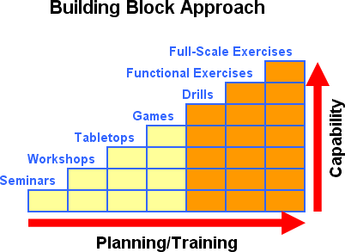

All exercises should begin with planning and exercise design meetings of some fashion that are coordinated between the planners and trainers, exercise specific expertise within the agency, and other stakeholders, to lay out the exercise goals, objectives, and timelines.

There are seven types of exercises defined within the HSEEP program.

* The first four of these (shown in yellow) are considered discussion-based exercises, which include planning and training.
* The last three (shown in orange) are operations-based exercises.

7-3

## Community Emergency Response Teams (CERT)

Following a major disaster, first responders who provide fire and medical services will not be able to meet the demand for these services. Factors as number of victims, communication failures, and road blockages will prevent people from accessing emergency services they have come to expect at a moment's notice through 9-1-1. People will have to rely on each other for help in order to meet their immediate lifesaving and life sustaining needs.

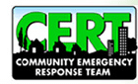

One also expects that under these kinds of conditions, family members, fellow employees, and neighbors will spontaneously try to help each other. This was the case following the Mexico City earthquake where

untrained, spontaneous volunteers saved 800 people. However, 100 people lost their lives while attempting to save others. This is a high price to pay and is preventable through training.

If we can predict that emergency services will not meet immediate needs following a major disaster, especially if there is no warning as in an earthquake, and people will spontaneously volunteer, what can government do to prepare citizens for this eventuality?

First, present citizens the facts about what to expect following a major disaster in terms of immediate services. Second, give the message about their responsibility for mitigation and preparedness. Third, train them in needed lifesaving skills with emphasis on decision making skills, rescuer safety, and doing the greatest good for the greatest number. Fourth, organize teams so that they are an extension of first responder services offering immediate help to victims until professional services arrive.

[The Community Emergency Response Team (CERT) Program](http://yorkcountypa.gov/emergency-services/emergency-management-office/volunteer-respond/community-emergency-response-team-cert.html) educates people about disaster preparedness for hazards that may impact their area and trains them in basic disaster response skills, such as fire safety, light search and rescue, team organization, and disaster medical operations. Using the training learned in the classroom and during exercises, CERT members can assist others in their neighborhood or workplace following an event when professional responders are not immediately available to help. CERT members also are encouraged to support emergency response agencies by taking a more active role in emergency preparedness projects in their community.

Currently there are no active CERT teams in Jefferson County, several individuals have received training over the past several years. Being a community-based program, Local EMC’s may be asked to assist in development of a team. The class IS-317 Introduction to CERT can be found at <http://training.fema.gov/is/courseoverview.aspx?code=IS-317>

8-1

## Voluntary Organizations Active in Disaster (VOAD)

VOAD is a national non-operational umbrella organization that gives each of its members the privilege of independently, but cooperatively, providing and implementing its resources when responding to disasters. VOAD is committed to the philosophy that the time to train, prepare, and become acquainted with each other is best achieved prior to the time of actual disaster response.



The member organizations offer a wide variety of services.

* Incident Canteen service
* Sheltering
* Housing (short term / long term)
* Clothing
* Mass feeding (1000 + capable with notice)
* Storm damage / debris cleanup / basement muck out
* Two-way radio communications (Public event safety, backup emergency communications)
* Warming / Cooling stations
* Counseling
* Threat and Risk Assessment (for business, schools, public buildings)
* Special Event planning
* Crowd / perimeter control
* Light Search & Rescue
* C.A.R.E. / Lost child search / Amber Alert support
* First Aid Station
* Assistance from county agencies (Meals on Wheels, MCU, etc.)

Local resources should be used. If there is still an unmet need, then turn to the American Red Cross. If the need still exists, they will coordinate activation of VOAD through EMA.

The following organizations are current active members of Jefferson County VOAD: American Red Cross – Greater PA Region

Salvation Army of Jefferson Pennsylvania

United Way of Jefferson County / 2-1-1

Jefferson County Community Action

Jefferson County Human Services

Jefferson County Housing Authority

Emergency Management Agency, Jefferson Co.

Jefferson County Area Agency on Aging

#### Long Term Recovery

Pennsylvania has experienced an increase in high-impact localized events. While damage from a disaster is significant to the community, the availability of federal funding to assist survivors has become increasingly limited.

A Multi Agency Resource Center (MARC) brings together multiple service providers to create a one-stop assistance center for disaster survivors. The scope and size of the MRC is entirely scalable and provides a mechanism to offer local and state resources as well as VOAD’s to assist with unmet needs.

Some of the common unmet needs of disaster survivors are:

* Legal Assistance
* Damage Assessment Documentation
* Debris Removal
* Document Replacement
* Accommodations for Domestic Animals
* Education & Job Training Assistance
* Employment Assistance
* Food and Nutrition
* Financial Assistance
* Funeral Assistance
* Functional Needs
* Household Goods
* Housing
* Emotional Assistance
* Utilities

## The National Incident Management System

[The National Incident Management System (NIMS)](https://www.fema.gov/national-incident-management-system) came to life from Homeland Security Presidential Directive (HSPD) 5, under the authority of President George W. Bush.

In 2004, the Department of Homeland Security published the first version of the National Incident Management System. In December, 2004, Governor Rendell signed a proclamation, mandating that NIMS is utilized for all incident management in the Commonwealth.

This system is designed to create a core set doctrine, concepts, principles, terminology, and organizational processes that enables effective, efficient, and collaborative incident management across all emergency management and incident response organizations and disciplines.

In other words, NIMS is a system in which an all-hazards approach is taken to manage and mitigate an emergency event. Additionally, the

system is flexible and adaptable to natural, man- made, small-, or large-scale events.

### National Response Framework

The National Response Framework (NRF) is the guide utilized to direct the nation on how to respond to catastrophes with an all-hazards approach.

Within the NRF, response principles, key roles, responsibilities, and structures which organize national response are discussed in detail. The framework binds local, state, federal, private sector, and non-government partners together.

Furthermore, the framework presents discussion to address special circumstances in which the Federal government may play a larger role while responding to incidents of federal interest or where states require significant response resources.

Finally, the framework ensures government executives, private sector and non-governmental organization (NGO) leaders, and emergency management practitioners across the nation understand their domestic incident response roles, responsibilities, and relationships in order to respond more effectively to any type of incident.

10-1

## Critical Incident Stress Management

The Jefferson County, Critical Incident Stress Management Team, consists of volunteers from multiple fields of experience. There are EMT’s, Fire Fighters, Chaplin’s, Psychologists, social workers, and others who work in the emergency services, who are trained to debrief or defuse emergency workers after a critical incident. Critical Incident Stress Debriefing (CISD) is a facilitator-led process conducted soon after a traumatic event with individuals considered to be under stress from trauma exposure. Participants are encouraged to describe their experience of the incident and its aftermath, followed by a presentation on common stress reactions and stress management. This early intervention process supports recovery by providing group support and linking affected individuals to further counseling and treatment services if necessary. The team can be contacted by calling the Jefferson County Department of Emergency Services, 814-849-1617. The dispatcher will take your message and forward to a team member, who will return your call.

If you need counseling or want help in other areas, please call 2-1-1 and they will provide you with a listing of agencies that may assist.

11-1

## Grant Management

[PEMA administers several grant programs.](http://www.pema.pa.gov/about/Pages/Grants.aspx#.U9e_4bHD_cs) The following apply to local governments:

### Description: http://ts3.mm.bing.net/images/thumbnail.aspx?q=1352930689338&id=609363f5ad6caf9afa0f039a7ffa45b9&url=http%3a%2f%2fwww.aceairinc.com%2fmoney.jpg%3fnxg_versionuid%3dpublishedFlood Mitigation Assistance Program

The Flood Mitigation Assistance Program (FMAP) is a pre-disaster mitigation program. FMAP is funded annually; a federal disaster declaration is not required. FMAP funding comes from the National Flood Insurance Program (NFIP). Only NFIP-insured homes and businesses are eligible for mitigation in this program. Funding for the FMAP is very limited. Applications must come from local governments or other eligible organizations; individuals cannot apply directly for the program. Applications for the FMAP are done electronically through FEMA’s e-Grants System. The federal cost share for an FMAP project

is 75 percent. At minimum, a FEMA-approved local flood mitigation plan is required before a project can be approved. Some funding is available for planning.

### Pre-Disaster Mitigation Program

The Pre-Disaster Mitigation Program (PDM) is an annually funded nationwide competitive grant program; a federal disaster declaration is not required. As with the FMAP, the program is open to any local governments or eligible organizations; individuals cannot apply directly for the program. Applications for the FMAP are done electronically through FEMA’s e-Grants System. The federal cost share for an FMAP project is 75 percent. At minimum, a FEMA-approved local flood mitigation plan is required before a project can be approved. Some funding is available for planning.

Because PDM is a nationwide program, applications from across the United States compete for available funds. The information required to compete a PDM application can be extensive because of the level of competition for funds. PEMA mitigation staff are available to assist local applicants with those demands and completing their e-Grant applications.

12-1

### Radiological Emergency Response Fund

The Radiological Emergency Response Fund (RERF), supported by fees assessed to nuclear power plants, is designed to provide financial assistance to the 26 designated risk and support counties, municipalities, school districts, volunteer organizations and State agencies in order to carry out the purposes of the Radiological Emergency Response Program.

The Radiological Emergency Response Program provides for the development of a detailed fixed nuclear emergency response plan for areas surrounding each nuclear electrical generation facility, nuclear fabrication and away-from-reactor storage facility located in the Commonwealth, the training and equipping of State and local emergency response personnel, the periodic exercise of the accident scenarios designated in the Nuclear Regulatory Commission emergency response plan applicable to each fixed nuclear facility, and the procurement of specialized supplies and equipment.

12-2



|  |
| --- |
| **Number:** |
| **D2022-02** |
| **Effective Date:** |
| July 5, 2022 |
| **Termination Date:** |
| N/A |
| **Rescinds Directive Number:** |
| 2017-02 |

**PEMA Directive**

|  |
| --- |
| **Subject:** |
| Commonwealth of Pennsylvania Emergency Management Certification Program |

|  |  |  |
| --- | --- | --- |
| **Scope:** |  |  |
| This Directive affects appointed county and municipal emergency management coordinators, their staff, and practitioners of emergency management from other public, private, and non-  governmental entities. | | |
|  | | |
| **Distribution:** |  | **By Direction of:** |
| * [www.pema.pa.gov](http://www.pema.pa.gov/) * County and Municipal Coordinators * Keystone Emergency Management Association * PA County Commissioners Association * PA State Association of Boroughs * PA State Association of Township Supervisors |  | David R. Padfield  Director, PA Emergency Management Agency |

1. **PURPOSE**



The purpose of this Directive is to prescribe the training required to develop and maintain competency in individuals serving as appointed county and municipal emergency management coordinators (EMC), their staff, and practitioners of emergency management from other agencies or organizations. Public comment from emergency management professionals at various levels of government and the public was part of this document’s development. It is designed to help emergency management practitioners at all levels work towards advancing their careers, achieve additional certifications from other entities as a means of professional development, and contribute to the professionalization of emergency management. Additionally, this certification program will ensure that the base of knowledge for all practitioners in emergency management within Pennsylvania is consistent.

1. **TITLE 35 AUTHORITIES**
   1. **Section 7502(b). County coordinator** – A coordinator shall be appointed in all counties with approval of the Director of the Agency. The executive officer or governing body of the county shall recommend a coordinator whose recommendation must be endorsed by the Director of the Agency prior to appointment by the Governor.

Bureau of Planning, Training & Exercise/ [RA-emtraining@pa.gov](mailto:RA-emtraining@pa.gov)

**Comments and Questions Regarding this Directive Should be Directed to:**

* 1. **Section 7502(c). Municipal level** – At the municipal level, the coordinator shall be appointed by the Governor upon recommendation of the executive officer or governing body of the political subdivision.
  2. **Section 7502(d). Qualifications**. – The coordinator shall be professionally competent and capable of planning, effecting coordination among operations agencies of government, and controlling coordinator operations by local emergency preparedness forces.
  3. **Section 7502(e). In-service training** – Each appointed coordinator (county or municipal) shall:
     1. Attend and successfully complete the first phase of the career development program as prescribed by the agency within one year after appointment. [Note: This will now be known as the Associate level.]
     2. Attend and successfully complete the second phase of career development program as prescribed by the agency within three years after appointment. [Note: This will now be known as the Professional level.]
     3. Attend basic and advanced seminars, workshops and training conferences called by the State Director and/or official having responsibility for providing the coordinator with in-service training.
     4. Failure to attend the instructions described in this subsection or failure to attend a prescribed training conference for a period of two consecutive years shall be cause for replacement. The State Director of Emergency Management may grant credit toward meeting the requirements of this subsection to appointed coordinators based on prior experience and training.
  4. **Section 7502(f). Responsibility for training** – Responsibility for the professional in-service training of each [appointed] coordinator rests with each successive higher political subdivision than the one in which the coordinator is functioning [e.g., PEMA is responsible for providing in-service training for county EMA; county EMAs are responsible for providing in-service training for municipal EMA].

1. **DEFINITIONS**
   1. **Agency:** The Pennsylvania Emergency Management Agency (PEMA).
   2. **Appointed Coordinator:** An EMC appointed by the jurisdictional governing body or agency at the county or municipal levels.
   3. **Associate Certification:** The requirements prescribed by the Director of the Agency to satisfy the “first phase of the career development program.” Appointed coordinators shall complete the appropriate program within one year after appointment. Attachment A provides the requirements for the Emergency Management Certification and Career Development Program.
   4. **County Coordinators:** Emergency Management Coordinator of one of the 67 counties in Pennsylvania.
   5. **Municipal Coordinator**: Coordinators in municipal or multiple-municipal regional emergency management organizations in Pennsylvania.
   6. **Practitioner:** Any professional practitioner of emergency management outside of county and municipal emergency management staff, to include PEMA staff. This includes specialized fields such as healthcare, schools, universities, private sectors, VOADs, or other state agencies.
   7. **Professional Certification:** The requirements prescribed by the Director of the Agency to satisfy the “second phase of the career development program.” Appointed coordinators shall complete the appropriate program within three years after appointment. Attachment A provides the requirements for the Emergency Management Certification and Career Development Program.
   8. **Staff:** Employees or volunteers of county or municipal emergency management agencies who are not the appointed coordinators. This includes the Deputy Director.
   9. **Training Records:** Documentation providing who was trained, when they were trained, and what skills they have mastered.
2. **GENERAL INFORMATION**
   1. The Director of the Agency, authorized under section 7502(e), prescribes the career development programs described herein for appointed county coordinators, appointed municipal coordinators, and staff to develop key competencies in emergency management.
   2. This Directive has been expanded to include a certification track for those emergency management practitioners who fall outside of the purview of Title 35, but still want to attain certification for professional development purposes. This is voluntary and optional for emergency management practitioners who fall outside of county and municipal government.
   3. This Directive has also been expanded to include a recertification requirement should the certified individual wish to maintain their certification. This is intended to keep career emergency management professionals current in the field, as well as allow emergency management professionals to use the certification towards additional professional development certifications, such as the International Association of Emergency Management (IAEM)’s Associate Emergency Manager (AEM) and Certified Emergency Manager (CEM), etc.
   4. Comprehensive emergency management involves an integrated all-hazards and all-risks approach to planning, response, recovery, and mitigation. The career development programs for the Pennsylvania emergency management community present similar material in classroom and self-study formats for both county and municipal coordinators and staff.
   5. The certification levels and both program descriptions are in Attachments A and B of this Directive. The accompanying checklists are provided as Attachments C - H of this Directive.
   6. This Directive is effective on the date of issue and applies to all municipal and county coordinators and their staff, as well as emergency management practitioners in state government, the private sector, non-governmental organizations (NGO), etc. Certifications granted under previous Directives will be grandfathered for a period of five (5) years, after which they will need to recertify as outlined in this Directive should they wish to maintain their certification.
   7. Individuals currently working towards a certification level under Directive 2017-02 shall have twelve (12) months from the date of this Directive to complete their certification under Directive 2017-02’s criteria. The recertification criteria will apply to these individuals.
   8. All certifications issued prior to this Directive’s Effective Date will remain valid for a period of five (5) years. After that date, should the individual wish to remain certified at the highest level, they will need to submit a recertification package.
   9. The appropriate Area Office Director shall review and verify that the county/municipal applicant has completed all required activities for certification and recommend the applicants for certification.
   10. PEMA Training & Exercise Division staff shall review and verify that the EM Practitioner applicant has completed all required activities for certification and recommend the applicant for certification.
   11. Recertification packets will be reviewed by PEMA Training and Exercise Division staff.
   12. PEMA Training & Exercise Division will forward all complete applications for recommendation to the Director. Incomplete applications will be returned to the applicant for correction and resubmission.
   13. Every effort will be made to process certification and recertification packets within 30 days of receipt at PEMA HQ. Longer processing times may occur depending on the volume of applications received.
   14. Requirements established under federal grant guidance shall be separate and distinct from this certification program (to include required NIMS courses as outlined in the [*Pennsylvania NIMS Implementation Strategy*](https://www.pema.pa.gov/Preparedness/NIMS/Pages/default.aspx)).
   15. Pre-requisites for coursework are not included in this Directive and should be completed independently.
3. **RESPONSIBILITIES**
   1. **Appointed County Coordinators**

Appointed county coordinators shall comply with the requirements of this Directive and complete the Associate and Professional levels of certification as required under Title 35, Section 7502 (e). Appointed county coordinators shall complete Associate certification within one year of appointment and Professional certification within three years of appointment.

* 1. **Appointed Municipal Coordinators**

Appointed municipal coordinators shall comply with the requirements of this Directive and complete the Associate and Professional levels of certification as required under Title 35, Section 7502(e). Appointed municipal coordinators shall complete Associate certification within one year of appointment and Professional certification within three years of appointment.

* 1. **Area Office Directors**

The PEMA Area Office Directors are responsible for initial review and concurrence with requests for certification and for forwarding these requests to the Training and Exercise Division for further review. The Area Offices shall maintain a training record for appointed county coordinators.

* 1. **County Staff**

County emergency management personnel, to include the deputy coordinator, should complete Associate and Professional levels of certification. County emergency management staff may be required to complete their county’s requirements in addition to PEMA’s. The certification program for staff personnel is the same for appointed county coordinators, except that the deputy and staff do not complete the certification exercise, exam, or the program review.

* 1. **Municipal Staff**

Municipal emergency management personnel, to include the deputy coordinator, should complete Associate and Professional levels of certification. Municipal emergency management staff may be required to complete local training requirements in addition to PEMA’s. The certification program for staff personnel is the same for appointed municipal coordinators.

* 1. **PEMA Director**

The PEMA Director shall issue certification as recommended by PEMA Training & Exercise Division.

* 1. **Practitioners**

Emergency management practitioners not at the county level (i.e., PEMA staff, hospital, school, university, private sector, etc.) are encouraged to complete the Associate and Professional levels of certification to help ensure their base of knowledge is identical to what county and municipal staff are required to take. *This is an optional certification process for this group.*

* 1. **Training and Exercise Division**

The Training and Exercise Division shall receive requests for county and municipal certification from the Area Office Directors and receive and review the practitioner submission packets. PEMA Training & Exercise Division will make recommendations on the applicants to the Director. Program changes may be recommended by PEMA Training & Exercise Division to the Director.

1. **CERTIFICATION AND RECERTIFICATION COURSES**
   1. Courses for certification and recertification come from the Federal Emergency Management Agency (FEMA) Independent Study (IS) program; the FEMA G-Series program (state delivery of FEMA programs); PEMA-developed curricula; Incident Command System (ICS) training programs, and other approved sources (such as the IAEM course listing), which may be a combination of virtual and/or classroom delivery. G-Series courses hosted by another state can be used to satisfy the requirements under this Directive if a state-level certificate is provided.
   2. Courses with the IS prefix are part of the FEMA Emergency Management Institute (EMI) IS program. FEMA EMI and IS program courses can be found on the [EMI](https://training.fema.gov/is/) [Website.](https://training.fema.gov/is/)
      1. FEMA occasionally updates the IS program courses; when this occurs, the numbering scheme following the course name is also updated. Courses that have been updated are identifiable by the ‘. a,’ ‘. b,’ (etc.) at the end of the course number. It is conceivable that the alphanumeric appendage to the course number will progress alphabetically as FEMA updates the courses. For that reason, this Directive does not include the specific version of each course to allow for flexibility.
      2. All iterations of IS courses will be accepted for certification; however, the latest version is strongly recommended to maintain currency.
      3. When a course needed for certification is removed by EMI or another institution due to updating or retiring it, that course will be waived if another acceptable alternative is not available. PEMA Training and Exercise Division may make modifications to the course listing as necessary to account for retired courses or courses under revision, and a notification of those changes will be sent out to county training officers and posted on PEMA’s website.
   3. Courses with the E/G/K/L prefixes are FEMA programs, some of which are delivered at the state level. In Pennsylvania, the G courses are taught by PEMA-approved instructors. All E/G/K/L courses may be requested through PEMA Training and Exercise Division, taken online if available in a virtual format, taken as a resident at EMI in Emmitsburg, MD, or can be held by a county using a qualified instructor that they procure directly. The qualified instructor list for G-series courses is available at each Area Office or by contacting PEMA Training and Exercise Division. “AWR,” “MGT,” etc. courses may be obtained from consortium schools.
   4. The following PEMA-developed courses are available to support coordinator training and provide more Pennsylvania-specific information. Courses may be obtained via TRAIN PA or the PEMA Area Offices, as indicated below:
      1. P-002: Duties and Responsibilities of the Emergency Management Coordinator (virtual or in person)
      2. P-003: PEMA Headquarters Orientation for County Emergency Management Coordinators (virtual or in person)
      3. P-004: Initial Damage Reporting (virtual or in person)
      4. P-010: Area Office Orientation (Only available at PEMA Area Offices)
      5. P-012: Resource Request Process Training (virtual)
2. **RECOGNITION OF PRIOR EXPERIENCE AND WAIVERS**
   1. Written justification and supporting documents must be provided for equivalency and/or experience credit for both training and certification exercises. The State Training Officer can approve other equivalent courses and/or previous experience on a case-by-case basis after review by appropriate subject matter expert(s) and PEMA leadership.
      1. Pre-approved courses that may be considered for equivalencies are available on the International Association of Emergency Managers’ website, here ([http://www.iaem.org/certification/resource-center/training-allocation-](http://www.iaem.org/certification/resource-center/training-allocation-tables) [tables](http://www.iaem.org/certification/resource-center/training-allocation-tables)).
      2. Courses taken as part of an Emergency Management-related degree from an accredited institution may be considered for equivalency. A copy of the course’s syllabus must be submitted to [ra-empqs@pa.gov](mailto:ra-empqs@pa.gov) along with the name of the course that the applicant is requesting that it be substituted for to determine whether it meets the same or similar objectives as the required course.
      3. County Coordinators requesting that real world experience be substituted for the certification exercise should submit a comprehensive package to the Area Office that includes examples of the coordinator serving in an EOC Manager (or equivalent) role during at least two longer duration (several operational periods), complex events. This should include Incident Action Plans (IAPs) showing the applicant in the EOC Manager role, completed Position Task Books (PTBs) for an EOC Manager or similar role, ICS 203s showing the applicant in an EOC Manager role, etc. (Checklist is provided as Attachment I to this Directive). Questions on acceptable documentation can be directed to [ra-empqs@pa.gov.](mailto:ra-empqs@pa.gov)
      4. Candidates requesting a waiver of time for certification shall submit a package containing documented proficiency in their position, as well as a recommendation letter from a superior. Packets can be sent to [ra-empqs@pa.gov.](mailto:ra-empqs@pa.gov)
3. **RECERTIFICATION**
   1. To ensure that emergency management personnel are remaining current within the field, recertification will be required every five (5) years for all Pennsylvania Professional Emergency Managers who wish to maintain that certification. Recertification will require the applicant to engage in training in each of the five mission areas in emergency management: Mitigation, Prevention, Protection, Response, and Recovery as well as professional contributions to the field.
   2. Applicants will be responsible for keeping track of when their recertification is due, and subsequently applying if they wish to maintain certification.
   3. Recertification requirements can be found in Attachment B of this Directive. Recertification Applications will be available on PEMA’s website, under the [Training and Exercise Page.](https://www.pema.pa.gov/Preparedness/Training-Exercises/For-Government-Partners/Pages/default.aspx)
   4. The recertification application packet will be evaluated by PEMA Training & Exercise personnel. Successful candidates will receive their recertification certificate via email. Candidates who need to provide additional documentation will be contacted via email.
4. **TRAINING RECORDS**
   1. PEMA Area Offices shall maintain training records for programs conducted for county and municipal coordinators and their staff. The Area Offices shall maintain training profiles for appointed county coordinators.
   2. County EMCs shall maintain rosters for all classes conducted by their agency and maintain a training profile for their staff, as well as local EMCs.
   3. Training records for EM Practitioners are the responsibility of the practitioners’ organization or the practitioner themselves to maintain.
   4. Transcripts from FEMA National Training & Exercise Division (NTED) providers are an acceptable form of documentation in lieu of certificates.
   5. PEMA Training & Exercise Division will maintain a record of all certifications and recertifications issued.
5. **SCHEDULES AND ANNOUNCEMENT OF COURSES**

Course schedules are available via the [Integrated Preparedness Calendar](https://www.pema.pa.gov/Preparedness/Training-Exercises/Pages/Pennsylvania-Integrated-Preparedness-Calendar.aspx) and/or through TRAIN PA. Please note that this may not be a comprehensive list. Federal Course announcements and schedules can be found on the [FEMA Training](https://training.fema.gov/) website.

1. **REVIEW AND MAINTENANCE**

This Directive will be reviewed every two years or when significant substantive changes occur to course availability.

Carbon Copy: Office of the Director

Office of the State Fire Commissioner Executive Deputy Director

Deputy Director for 9-1-1 Deputy Director for Operations Deputy Director for Recovery Director of Administration

Director, Innovation & Business Transformation External Affairs Office

Communications Office Chief Counsel’s Office

Legislative Affairs/Policy Office Bureau of Technological Hazards

Bureau of Planning, Training, and Exercise Bureau of Grants Management

PEMA Area Offices PEMA Website

**Attachments:**

Attachment A Certification Levels and Program Descriptions Attachment B Recertification Program Description Attachment C County Associate Certification Checklist Attachment D County Professional Certification Checklist Attachment E Municipal Associate Certification Checklist Attachment F Municipal Professional Certification Checklist Attachment G Practitioner Associate Certification Checklist Attachment H Practitioner Professional Certification Checklist

Attachment I Recognition of Prior Experience in Lieu of Certification Exercise for EMCs Checklist

**ATTACHMENT A**

**CERTIFICATION LEVELS AND PROGRAM DESCRIPTION**

* 1. **County EMC and Staff Certification Levels and Program Description:**
     1. County Associate Emergency Management Certification requires successful completion of the following:
        1. Coursework:
           + P-002: Duties and Responsibilities (in-person or virtual)
           + P-003: Headquarters Orientation *Required for coordinators. County staff may attend at the county’s discretion (in-person or virtual)
           + P-004: Initial Damage Reporting (in-person or virtual)
           + P-010: Area Office Orientation (in person)
           + P-012: Resource Request Process Training (virtual)
           + IS-29: Public Information Officer Awareness
           + G-191: ICS/EOC Interface (classroom or virtual)
           + IS-230: Fundamentals of Emergency Management
           + G-235: Emergency Planning
           + IS-1000: Public Assistance
           + IS-2000: National Preparedness Goal and System Overview
           + IS-2200: Basic Emergency Operations Center Functions
           + IS-2500: National Prevention Framework, an Introduction
           + IS-2600: National Protection Framework, an Introduction
           + IS-2700: National Mitigation Framework, an Introduction
           + IS-2900: National Disaster Recovery Framework Overview
           + IS-2901: Community Lifelines
        2. Attend two In-Service Training (IST) sessions provided by PEMA (annually).
        3. Attend one emergency management related conference annually (coordinator only).
        4. Achievement of a passing score on written exam (appointed coordinator only).
        5. Successful completion of a functional exercise designed by PEMA to meet required components, or submission of a package that documents real world experience in lieu of an exercise (appointed Coordinator only). The checklist for substitution of real world experience can be found in Attachment I.
        6. Written endorsement by the PEMA Area Director.
        7. Submission of County Associate Certification Checklist (See Attachment C), with all signature blocks completed along with all supporting documentation attached.
     2. County Professional Emergency Management Certification requires successful completion of the following:
        1. Coursework:
           + AWR-401W: Threat and Hazard Identification and Risk Assessment and Stakeholder Preparedness Review (virtual)
           + AWR-923W: Radiological Emergency Management (virtual)
           + IS-5: An Introduction to Hazardous Materials
           + IS-26: Guide to Points of Distribution
           + K/L-146: Homeland Security Exercise and Evaluation Program Training Course (HSEEP)
           + G-271: Hazardous Weather and Flooding Preparedness
           + G-290: Basic Public Information Officers Course or E/L- 105: Public Information Basics*
           + G-393: Mitigation for Emergency Managers
           + IS-922: Applications of GIS for Emergency Management
           + IS-1300: Introduction to Continuity of Operations
           + K/E-2300: Intermediate Emergency Operations Center Functions
        2. Service at the Associate Certification level for one year.
        3. Attend two IST sessions provided by PEMA (annually).
        4. Attend one emergency management related conference annually (coordinator only).
        5. Written endorsement of PEMA Area Director.
        6. Completion of all requirements no later than three years following appointment (appointed coordinator only).
        7. Submission of County Professional Certification Checklist (See Attachment D), with all signature blocks completed along with all supporting documentation attached.

*The G-290 course will be retired by FEMA in the Fall of 2022. PEMA will continue to offer/accept the G-290 course until December 31, 2023 while L-105 instructors are trained for in-state deliveries.

* 1. **Appointed Municipal EMC and Staff Certification Levels and Program Description:**
     1. Municipal Associate Emergency Management Certification requires successful completion of the following:
        1. Coursework:
           + P-002: Duties and Responsibilities (in-person or virtual)
           + P-004: Initial Damage Reporting (in-person or virtual)
           + P-012: Resource Request Process Training (virtual)
           + IS-29: Public Information Officer Awareness
           + G-191: ICS/EOC Interface (classroom or virtual)
           + IS-230: Fundamentals of Emergency Management
           + G-235: Emergency Planning
           + IS-1000: Public Assistance
           + IS-2000: National Preparedness Goal and System Overview
           + IS-2200: Basic Emergency Operations Center Functions
           + IS-2500: National Prevention Framework, an Introduction
           + IS-2600: National Protection Framework, an Introduction
           + IS-2700: National Mitigation Framework, an Introduction
           + IS-2900: National Disaster Recovery Framework Overview
           + IS-2901: Community Lifelines
        2. Attend two In-Service Training (IST) sessions provided by PEMA or the county EMA.
        3. Written endorsement of the jurisdiction’s county coordinator.
        4. Submission of Municipal Associate Certification Checklist (See Attachment E), with all signature blocks completed along with all supporting documentation attached.

1. Municipal Emergency Management Professional Certification requires successful completion of the following:
   1. Coursework:
      * AWR-401W: Threat and Hazard Identification and Risk Assessment and Stakeholder Preparedness Review (virtual)
      * AWR-923W: Radiological Emergency Management (virtual)
      * IS-5: An Introduction to Hazardous Materials
      * IS-26: Guide to Points of Distribution
      * IS-120: Introduction to Exercises
      * G-271: Hazardous Weather and Flooding Preparedness
      * G-290: Basic Public Information Officers Course or E/L- 105: Public Information Basics*
      * G-393: Mitigation for Emergency Managers
      * IS-922: Applications of GIS for Emergency Management
      * IS-1300: Introduction to Continuity of Operations
      * K/E-2300: Intermediate Emergency Operations Center Functions
   2. Service at the Associate Certification level for one year.
   3. Attend two IST sessions provided by PEMA or county EMA.
   4. Written endorsement of jurisdiction’s county coordinator.
   5. Submission of Municipal Professional Certification Checklist (See Attachment F), with all signature blocks completed along with all supporting documentation attached.

*The G-290 course will be retired by FEMA in the Fall of 2022. PEMA will continue to offer/accept the G-290 course until December 31, 2023 while L-105 instructors are trained for in-state deliveries.

* 1. **Emergency Management Practitioner Certification Levels and Program Description**
     1. Emergency Management Associate Practitioner Certification requires successful completion of the following:
        1. Coursework:
           + P-002: Duties and Responsibilities (in-person or virtual)
           + P-004: Initial Damage Reporting (in-person or virtual)
           + IS-29: Public Information Officer Awareness
           + G-191: ICS/EOC interface (classroom or virtual)
           + IS-230: Fundamentals of Emergency Management
           + G-235: Emergency Planning
           + IS-1000: Public Assistance
           + IS-2000: National Preparedness Goal and System Overview
           + IS-2200: Basic Emergency Operations Center Functions
           + IS-2500: National Prevention Framework, an Introduction
           + IS-2600: National Protection Framework, an Introduction
           + IS-2700: National Mitigation Framework, An Introduction
           + IS-2900: National Disaster Recovery Framework Overview
           + IS-2901: Community Lifelines
        2. Attend two emergency management-related in-service trainings per year (via a conference or another emergency management-related professional development opportunity).
        3. Written endorsement of organization’s senior management.
        4. Submission of Associate Practitioner Certification Checklist (See Attachment G), with all signature blocks completed along with all supporting documentation attached.
     2. Emergency Management Practitioner Professional Certification requires successful completion of the following:
        1. Coursework:
           + AWR-401W: Threat and Hazard Identification and Risk Assessment and Stakeholder Preparedness Review (virtual)
           + AWR-923W: Radiological Emergency Management (virtual)
           + IS-5: An Introduction to Hazardous Materials
           + K/L-146: Homeland Security Exercise and Evaluation Program Training Course (HSEEP)
           + G-271: Hazardous Weather and Flooding Preparedness
           + G-290: Basic Public Information Officers Course or E/L- 105: Public Information Basics*
           + G-393: Mitigation for Emergency Managers
           + IS-1300: Introduction to Continuity of Operations
           + K/E-2300: Intermediate Emergency Operations Center Functions
        2. Service at the Associate Certification level for one year.
        3. Attend two emergency management-related in service trainings per year (via a conference or another emergency management-related professional development opportunity).
        4. Written endorsement of organization’s senior management.
        5. Submission of Professional Practitioner Certification Checklist (See Attachment H), with all signature blocks completed along with all supporting documentation attached.

*The G-290 course will be retired by FEMA in the Fall of 2022. PEMA will continue to offer/accept the G-290 course until December 31, 2023 while L-105 instructors are trained for in-state deliveries.

**ATTACHMENT B**

**EMERGENCY MANAGEMENT RECERTIFICATION REQUIREMENTS**

All current EM Professionals in any category holding the Professional Certification who wish to maintain that certification will need to re-certify at five year intervals. To re-certify, the following must be submitted:

1. Recertification application cover sheet (can be found on PEMA website)
2. A minimum of 75 Continuing Education Training Hours in 3 of the 5 mission areas (as follows; please include the training sheet found in the application packet):
   1. Prevent-related training (max of 25 hours)
   2. Protect-related training (max of 25 hours)
   3. Respond-related training (max of 25 hours)
   4. Recover-related training (max of 25 hours)
   5. Mitigation-related training (max of 25 hours)

**Note:** Training hours submitted cannot be more than five years old at the time of recertification. Single trainings cannot count for more than 25 hours, regardless of length of course. Individual trainings may only count for one Mission Area.

1. Four (4) contributions to the emergency management profession since the date of last certification/re-certification, but no older than five years (submit documentation with re- certification packet; only one contribution per category will be counted per recertification period). Contributions that count are as follows:
   1. **Membership** in either KEMA, NEMA, or IAEM for at least three of the previous five years. Verify by providing a copy of membership information or invoice for membership.
   2. **Elected or Appointed Leadership** in an emergency management organization or committee. Examples include: KEMA Executive Board, IAEM committees, LEPC leadership, etc. Verify by providing appointment letter or minutes describing the election/appointment.
   3. **Speaking/Presenting** in a conference or panel participation relating to emergency management for a minimum of 30 minutes. Examples include presenting at PEMA In-Service Trainings, KEMA Conference, IAEM Conferences, FEMA Conferences/Symposiums/Technical Assistances, etc. Verify by providing a letter from the organizer, agenda with times showing a presentation of a minimum of 30 minutes.
2. **Instructing** PEMA, FEMA or ICS courses as a PEMA or OSFC-qualified instructor, instructor through an Educational Training Authority (ETA), or through FEMA (EMI/NFA/Consortium School). Verify by providing a letter from the hosting entity outlining the course(s) taught with dates.
3. **Publication** of an emergency management news article in a newsletter, newspaper, or journal, a research paper (Advanced or Executive Academy, educational institution, etc.), or a book or other credible instructional document. Verify by providing a copy of the published work (or a link to it, if a book/instructional document. Applicant’s name should clearly be identifiable).
4. **Awards or special recognition** within the emergency management community or in conjunction with an emergency preparedness activity, activation, or response. Examples can include (but are not limited to): awards from FEMA, PEMA, KEMA, IAEM, NEMA, and/or a state, county, or local elected official as part of a disaster response or preparedness initiative.
5. **Legislative Engagement:** Have an informational interaction or correspondence with a State or Federal legislative representative on an emergency management- related issue. Examples may include testifying before a legislative Committee, sitting on a legislative committee, advocating for a change to legislation that helps emergency management via a meeting or working group, or correspondence with (to and from) a legislator. Verify by providing copies of the correspondence, copies of testimony before Legislature, documentation of advocacy work on EM legislation/issues, committee charter showing applicant’s name as a member, etc.



|  |  |  |
| --- | --- | --- |
| **Name:**  **Title:** |  | **Email:** |
| **Agency:**  **Applicant Position:** | **Appointed Coordinator** | **FEMA SID #:**  **Staff** |

|  |  |  |
| --- | --- | --- |
| Course | Date Completed | Certification Enclosed |
| P-002: Duties and Responsibilities (In-person or Virtual) |  |  |
| P-003: Headquarters Orientation - Required for coordinators and deputies. County staff may attend at the county's discretion. (In-person or Virtual) |  |  |
| P-004: Initial Damage Reporting (In-person or Virtual) |  |  |
| P-010: Area Office Orientation (at Area Office Only) |  |  |
| P-012: Resource Request Process Training (Virtual) |  |  |
| IS-29: Public Information Officer Awareness |  |  |
| G-191: ICS/EOC Interface (Classroom or Virtual) |  |  |
| IS-230: Fundamentals of Emergency Management |  |  |
| G-235: Emergency Planning |  |  |
| IS-1000: Public Assistance |  |  |
| IS-2000: National Preparedness Goal and System Overview |  |  |
| IS-2200: Basic Emergency Operations Center Functions |  |  |
| IS-2500: National Prevention Framework, an Introduction |  |  |
| IS-2600: National Protection Framework, an Introduction |  |  |
| IS-2700: National Mitigation Framework, an Introduction |  |  |
| IS-2900: National Disaster Recovery Framework Overview |  |  |
| IS-2901: Community Lifelines |  |  |
| Attend two In-Service Training (IST) Sessions provided by PEMA annually |  |  |
| Attend one emergency management related conference annually (coordinator only) |  |  |

|  |  |  |
| --- | --- | --- |
| Achievement of a passing score on written exam (coordinator only) |  |  |
| Successful completion of a functional exercise designed by PEMA to meet required components, or submission of a package that documents real world experience in lieu of an exercise (Appointed Coordinator only) |  |  |
| Written Endorsement of PEMA Area Director |  |  |

**County Agency Recommendation: PEMA Area Office Recommendation:**

**Signature: Printed Name: Agency:**

**Date:**

**Signature:**

**Printed Name:**

**Area Office: CAO EAO WAO Date:**

**PEMA Training & Exercise Division Review:**

**Verified & Recommended**

**Signature:**

**Printed Name: Date:**

**Signed Certificate:**



|  |  |  |
| --- | --- | --- |
| **Name:**  **Title:** |  | **Email:** |
| **Agency:**  **Applicant Position:** | **Appointed Coordinator** | **FEMA SID #:**  **Staff** |

|  |  |  |
| --- | --- | --- |
| Course | Date Completed | Certification Enclosed |
| AWR-401W: Threat and Hazard Identification and Risk Assessment and Stakeholder Preparedness Review (Virtual) |  |  |
| AWR-923W: Radiological Emergency Management (Virtual) |  |  |
| IS-5: An Introduction to Hazardous Materials |  |  |
| IS-26: Guide to Points of Distribution |  |  |
| K/L-146: Homeland Security Exercise and Evaluation Program Training Course (HSEEP) |  |  |
| G-271: Hazardous Weather and Flooding Preparedness |  |  |
| G-290: Basic Public Information Officers Course or E/L-105: Public Information Basics |  |  |
| G-393: Mitigation for Emergency Managers |  |  |
| IS-922: Applications of GIS for Emergency Management |  |  |
| IS-1300: Introduction to Continuity of Operations |  |  |
| K/E-2300: Intermediate Emergency Operations Center Functions |  |  |
| Service at the Associate Certification level for one year |  |  |
| Attend two In-Service Training (IST) Sessions provided by PEMA annually |  |  |
| Attend one emergency management related conference annually (coordinator only) |  |  |
| Written Endorsement of PEMA Area Director |  |  |
| Completion of all requirements no later than three years following appointment (coordinator only) |  |  |

**County Agency Recommendation: PEMA Area Office Recommendation:**

**Signature: Signature:**

**Printed Name: Printed Name:**

**Agency: Area Office: CAO EAO WAO**

**Date: Date:**

**PEMA Training & Exercise Division Review:**

**Verified & Recommended**

**Signature:**

**Printed Name:**

**Date:**

**Signed Certificate:**

**Expiration Date (5 years):**



|  |  |  |
| --- | --- | --- |
| **Name:**  **Title:** |  | **Email:** |
| **Agency:**  **Applicant Position:** | **Appointed Coordinator** | **FEMA SID #:**  **Staff** |

|  |  |  |
| --- | --- | --- |
| Course | Date Completed | Certification Enclosed |
| P-002: Duties and Responsibilities (In-person or Virtual) |  |  |
| P-004: Initial Damage Reporting (In-person or Virtual) |  |  |
| P-012: Resource Request Process Training (Virtual) |  |  |
| IS-29: Public Information Officer Awareness |  |  |
| G-191: ICS/EOC Interface (Classroom or Virtual) |  |  |
| IS-230: Fundamentals of Emergency Management |  |  |
| G-235: Emergency Planning |  |  |
| IS-1000: Public Assistance |  |  |
| IS-2000: National Preparedness Goal and System Overview |  |  |
| IS-2200: Basic Emergency Operations Center Functions |  |  |
| IS-2500: National Prevention Framework, an Introduction |  |  |
| IS-2600: National Protection Framework, an Introduction |  |  |
| IS-2700: National Mitigation Framework, an Introduction |  |  |
| IS-2900: National Disaster Recovery Framework Overview |  |  |
| IS-2901: Community Lifelines |  |  |
| Attend two In-Service Training (IST) Sessions provided by PEMA or the County EMA |  |  |
| Written Endorsement of Jurisdiction’s County Coordinator |  |  |

**County Agency Recommendation: PEMA Area Office Recommendation:**

**Signature: Signature:**

**Printed Name: Printed Name:**

**Agency: Area Office: CAO EAO WAO**

**Date: Date:**

**PEMA Training & Exercise Division Review:**

**Verified & Recommended**

**Signature:**

**Printed Name: Date:**

**Signed Certificate:**



|  |  |  |
| --- | --- | --- |
| **Name:**  **Title:** |  | **Email:** |
| **Agency:**  **Applicant Position:** | **Appointed Coordinator** | **FEMA SID #:**  **Staff** |

|  |  |  |
| --- | --- | --- |
| Course | Date Completed | Certification Enclosed |
| AWR-401W: Threat and Hazard Identification and Risk Assessment and Stakeholder Preparedness Review (Virtual) |  |  |
| AWR-923W: Radiological Emergency Management (Virtual) |  |  |
| IS-5: An Introduction to Hazardous Materials |  |  |
| IS-26: Guide to Points of Distribution |  |  |
| IS-120: An Introduction to Exercises |  |  |
| G-271: Hazardous Weather and Flooding Preparedness |  |  |
| G-290: Basic Public Information Officers Course or E/L-105: Public Information Basics |  |  |
| G-393: Mitigation for Emergency Managers |  |  |
| IS-922: Applications of GIS for Emergency Management |  |  |
| IS-1300: Introduction to Continuity of Operations |  |  |
| K/E-2300: Intermediate Emergency Operations Center Functions |  |  |
| Service at the Associate Certification level for one year. |  |  |
| Attend two In-Service Training (IST) Sessions provided by PEMA or the County EMA |  |  |
| Written Endorsement of jurisdiction's County Coordinator |  |  |
| Completion of all requirements no later than three years following appointment (Appointed Coordinator only) |  |  |

**County Agency Recommendation: PEMA Area Office Recommendation:**

**Signature: Signature:**

**Printed Name: Printed Name:**

**Agency: Area Office: CAO EAO WAO**

**Date: Date:**

**PEMA Training & Exercise Division Review:**

**Verified & Recommended**

**Signature:**

**Printed Name:**

**Date:**

**Signed Certificate:**

**Expiration Date (5 years):**

**Name:**

**Title: Email:**

**Organization: FEMA SID #:**

**Applicant Position:**

|  |  |  |
| --- | --- | --- |
| Course | Date Completed | Certification Enclosed |
| P-002: Duties and Responsibilities (Virtual) |  |  |
| P-004: Initial Damage Reporting (Virtual) |  |  |
| IS-29: Public Information Officer Awareness |  |  |
| G-191: ICS/EOC Interface (Classroom or Virtual) |  |  |
| IS-230: Fundamentals of Emergency Management |  |  |
| G-235: Emergency Planning |  |  |
| IS-1000: Public Assistance |  |  |
| IS-2000: National Preparedness Goal and System Overview |  |  |
| IS-2200: Basic Emergency Operations Center Functions |  |  |
| IS-2500: National Prevention Framework, an Introduction |  |  |
| IS-2600: National Protection Framework, an Introduction |  |  |
| IS-2700: National Mitigation Framework, an Introduction |  |  |
| IS-2900: National Disaster Recovery Framework Overview |  |  |
| IS-2901: Community Lifelines |  |  |
| Attend two emergency management related In-Service Training (IST) Sessions per year (via a conference or another emergency management related professional development opportunity) |  |  |
| Written Endorsement of organization’s senior management |  |  |

**Organization’s Recommendation:**

**Signature:**

**Printed Name:**

**Agency:**

**Date:**

**PEMA Training & Exercise Division Review:**

**Verified & Recommended**

**Signature:**

**Printed Name:**

**Date:**

**Signed Certificate:**

**Name:**

**Title: Email:**

**Organization: FEMA SID #:**

**Applicant Position:**

|  |  |  |
| --- | --- | --- |
| Course | Date Completed | Certification Enclosed |
| AWR-401W: Threat and Hazard Identification and Risk Assessment and Stakeholder Preparedness Review (Virtual) |  |  |
| AWR-923W: Radiological Emergency Management (Virtual) |  |  |
| IS-5: An Introduction to Hazardous Materials |  |  |
| IS-26: Guide to Points of Distribution |  |  |
| K/L-146: Homeland Security Exercise and Evaluation Program Training Course (HSEEP) |  |  |
| G-271: Hazardous Weather and Flooding Preparedness |  |  |
| G-290: Basic Public Information Officers Course or E/L-105: Public Information Basics |  |  |
| G-393: Mitigation for Emergency Managers |  |  |
| IS-922: Applications of GIS for Emergency Management |  |  |
| IS-1300: Introduction to Continuity of Operations |  |  |
| K/E-2300: Intermediate Emergency Operations Center Functions |  |  |
| Service at the Associate level for one year |
| Attend two emergency management related In-Service Training (IST) Sessions per year (via a conference or another emergency management related professional development opportunity). |
| Written Endorsement of organization’s senior management. |  |  |

**Organization Recommendation:**

**Signature:**

**Printed Name:**

**Agency:**

**Date:**

**PEMA Training & Exercise Division Review:**

**Verified & Recommended**

**Signature:**

**Printed Name:**

**Date:**

**Signed Certificate:**

**Expiration Date (5 years):**

**Applicant’s Name:**  **Applicant’s County:**  **Date of Submission by County: Date of Area Office Review:**

|  |  |  |
| --- | --- | --- |
| **Step** | **Requirement** | **Completed (check off)** |
| * **County Coordinator has submitted a comprehensive packet of documentation of real-world experience (minimum of 2 large, complex incidents) showing they can meet the following relevant objectives:** | * Activation of EOC |  |
| * Directing EOC operations |  |
| * Gathering/providing information (ie: situational awareness) |  |
| * Identify/addressing issues |  |
| * Prioritize and provide resources |  |
| * Support & coordinate the incident response |  |
| * Demobilization of the EOC |  |
| * **The EMC has supplied the following documentation for each incident:** | * ICS 203’s showing the applicant in the EOC Manager (or equivalent) role |  |
| * Incident Action Plans from the incidents |  |
| * Situation Reports from the incidents |  |
| * After Action Report for the incident |  |
| * **(Optional)** Other documents that show the complexity of the incident and experience of the applicant as an EOC Manager during a longer duration (ie: WebEOC documentation, completed Position Task Books for EOC Manager, etc.) |  |

Revised: 4/8/2022

***PEMA Area Office Recommendation:***

***I have reviewed this submission and agree that the documentation provided meets the required objectives and shows that this applicant has met the requirements to use real world experience in lieu of a certification exercise.***

Signature:

Printed Name: Title: Area Office: EAO  CAO  WAO 

Date:

***Training & Exercise Division Supervisor or Planning, Training, & Exercise Bureau Director Recommendation:***

Signature:

Printed Name: Title: Date:

***Deputy Director for Operations Approval:***

Approved Denied

Signature:

Printed Name: Title:

Date:

Revised: 4/8/2022

(Date)

(Director Name) Director

Jefferson County Department of Emergency Services

560 Service Center Road

Brookville, PA 15825

Dear (Director Name),

I am interested in applying for the Municipal Coordinator (Level) certification through PEMA. I have enclosed copies of the required certificates for your records. After receiving this certification, I look forward to working with you in the future to achieve both the advanced and the professional certifications.

Thank you for your consideration (Your Name)

(Title and Municipality)

## Emergency Manager’s Toolkit

Welcome to the Emergency Manager Toolkit. This toolkit contains many resources that can be used to build emergency management capabilities.

The toolkit is divided into sections by topic. Each topic includes a number of resources. The topics include:

Preparedness Toolkit Response Toolkit Recovery Toolkit Mitigation Toolkit Media Toolkit Communications Toolkit

14-1

# Preparedness Toolkit

# 15-1

### Preparedness Checklists

The checklists provide a guide to actions during the preparedness phase of an emergency and an overview of what a local emergency management program should address.

#### Review the Contents of the EOP.

❏ Review threat assessment - flood plains, storm surge areas, etc.

❏ Develop, identify and implement preparatory actions.

❏ Check and list critical forms needed - Declaration, IDA, Sitrep

❏ Determine likely area(s) of impact.

#### Verify Communications Pathways (Up, Down, Lateral).

❏ Surrounding localities.

❏ Supporting agencies.

❏ Operations components--fire, police, PW, RACES, emergency cell support, etc.

❏ Public information plan/hotlines.

❏ Establish and Test Information Resources (in and out).

❏ Internet/Web site.

❏ Weather.

❏ Media, Print, TV, Cable and Radio.

#### Establish Briefing Schedules.

❏ Executives--watches/warnings, Declaration process, activation of EOP, etc.

❏ Elected officials.

❏ Public safety elements.

❏ Emergency Operations Center participants.

#### Determine Staffing Levels.

❏EOC augmentation/activation/recall.

❏Shift changes for public safety and other response personnel.

❏Estimate shelter demands (ARC Chapter, volunteers, RACES, etc.).

❏Establish public facility closing and opening times.

#### Check Critical Systems Readiness.

❏EOC--critical staff, resources and reports.

❏Public safety.

❏Utilities/PW/private/LEPC.

❏Media.

❏Mass care/schools/public health (food holdings/power).

❏Power generation--service ability/fuel levels.

❏Review and confirm contracted services.

❏Accounting and cost capture processes.

❏Review Continuity of Operations Plan (COOP)/Continuity of Government (COG) Plan.

❏Declare a Local Emergency.

❏Activate Staff and Logistical Support for the EOC.

❏Prepare for Response.

### Sample Hazard Identification Survey

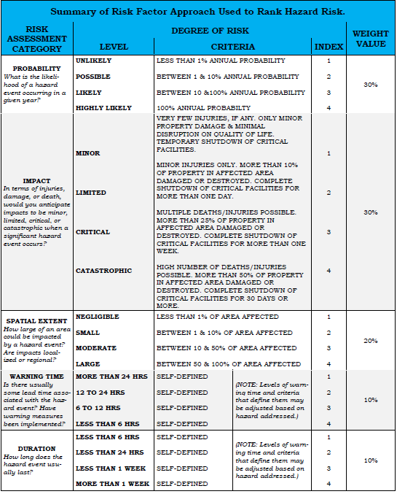

**The Local Emergency Operations Plan**

Section 7503(1) of the Emergency Management Services Code (the Code) (35 Pa. C.S. Section 7101 et seq.) mandates that “each political subdivision” in the Commonwealth “…prepare, maintain and keep current” an emergency operations plan “…for the prevention and minimization of injury and damage caused by disaster” within the municipality. Each municipality shall prepare and adopt its own emergency operations plan or, through an Inter- governmental Cooperation Agreement (ICA – sample attached), prepare and adopt an emergency operations plan with one or more other political subdivisions located within the same county. This directive highly encourages multi-jurisdiction planning and ICAs.

PEMA also wants to encourage all municipalities to shift their attention and efforts away from the “plan” to a more comprehensive and meaningful “planning process” that includes not only an EOP but also a more dynamic set of checklists and a complete and accurate notification and resource manual. By placing more emphasis on a municipality’s planning process instead of on the preparation of its written plan, PEMA believes that all elected officials, emergency management coordinators and their staffs will be better prepared to respond to, recover from and mitigate actual or potential disaster emergencies within their municipalities. This will, in turn, better protect the health, safety and welfare of the municipality’s citizens.

The document is promulgated by a municipality’s elected body, through the passage of a resolution, which describes the hazards, vulnerabilities, emergency management situations and assumptions that affect the municipality, the concept of operations during an emergency, and the various roles and assignments of the elected officials, emergency management coordinator and other emergency response personnel, whether paid or volunteer. The local EOP is consistent with the National Incident Management System (NIMS) and the Pennsylvania State Emergency Operations Plan. The local EOP is a public document.

The municipal elected body is responsible for review and approval/promulgation of the EOP.

A local EOP must be re-promulgated when a majority of the municipality’s elected body decides to make any substantive changes to the municipal EOP.

The local EOP must be reviewed at least every 24 months, if not re-promulgated sooner. The review may be done by the elected board or any person designated by the board (e.g. the Emergency Management Coordinator) to do the review. The review will assure that the plan is consistent with current laws and doctrine, that assumptions in the plan are still valid and that the plan is still workable. The review will be appropriately documented.

15-7

Should the review indicate that substantive changes to the plan are in order, a recommendation to this effect will be made to the board of elected officials.

#### Local emergency response functional checklists

The checklists are a separate document that is intended to supplement the local EOP by establishing a detailed list of emergency response actions to be performed by elected officials, the emergency management coordinator and other emergency response personnel during the occurrence of an actual or potential disaster emergency within the community. The checklists are reviewed and revised by the emergency management coordinator or another individual selected by the elected officials. This review will occur after the political subdivision, county or state conducts an emergency management exercise or drill or based upon recommendations contained in exercise or real event after-action reports. The checklists may contain personal information that is not subject to Pennsylvania’s Right-to-Know Law and does not need to be formally promulgated.

The municipal emergency management coordinator, her/his designee, or another person selected by the elected officials is responsible for review of the checklists.

Even if circumstances do not warrant a change in the local EOP, the person responsible for evaluating the effectiveness of the municipality’s functional checklists must review the checklists and make any necessary updates and revisions based upon the following:

* At least every 24 months, a review of the checklists for changes in personnel, procedures, doctrine, demographics or available resources.
* Observations or lessons learned after a state, county and/or municipality-sponsored exercise or drill and/or any recommendations contained in an after-action report of an exercise or drill
* Observations or lessons learned during or after the occurrence of an actual emergency response incident within the municipality or county.

#### Notification and Resource Manual

The Notification and Resource Manual (NARM) is a separate document that is intended to supplement the local EOP and the local emergency response checklists by providing contact information for those who need to be notified during an emergency, and by establishing a comprehensive list of emergency response personnel, equipment, supplies and other resources that can be mobilized and used during an actual or potential disaster emergency.

15-8

The Notification and Resource Manual is consistent with and uses terminology from the NIMS. The notification and Resource Manual is periodically reviewed and updated by the emergency management coordinator or another individual selected by the elected officials. As a result, this document is subject to frequent content changes. It may contain personal information that is not subject to Pennsylvania’s Right-to-Know Law and does not need to be formally promulgated.

The emergency management coordinator, his/her designee, or another person selected by the municipality’s elected officials is responsible for maintenance and update of the NARM.

Even if circumstances do not warrant a change in the EOP, the person responsible for evaluating the effectiveness of the municipality’s NARM must review the checklists and make any necessary updates and revisions based upon the following:

* At least every three months, an update of the manual for any necessary changes, additions or deletions to the notification and resource lists is conducted. Changes are reported to the elected officials when deemed appropriate.
* At least every 12 months, a thorough review of the notification and resource manual for any serious deficiencies, lack of personnel or other resources or other related problems is conducted. These are reported to the elected officials and the appropriate county emergency management agency.

A sample of the Local Emergency Operations Plan can be found in the CEM planner on the PEMA website.

15-9

*Sample Municipal ICA*

CITY/BOROUGH/TOWNSHIP OF

COUNTY, PENNSYLVANIA∗ ORDINANCE NO.

#### AN ORDINANCE OF THE CITY/BOROUGH/TOWNSHIP OF ,

**COUNTY, PENNSYLVANIA, PROVIDING FOR ENTERING INTO AN INTERGOVERNMENTAL COOPERATION AGREEMENT WITH OTHER MUNICIPALITIES LOCATED WITHIN COUNTY, PENNSYLVANIA, FOR THE PURPOSE OF ESTABLISHING ONE JOINT EMERGENCY OPERATIONS PLAN FOR THOSE PARTICIPATING MUNICIPALITIES.**

WHEREAS, certain municipalities located within County, Pennsylvania, desire to enter into an Intergovernmental Cooperation Agreement to adopt a joint Emergency Operations Plan as their municipal operations plan; and

WHEREAS, said municipalities, for the purpose of carrying the provisions of the Intergovernmental Cooperation Act into effect, deem it appropriate to enter into such agreement; and

WHEREAS, said municipalities have determined that the residents of each municipality will be best served by adopting the joint Emergency Operations plan as their own plan rather than having numerous, separate emergency operations plans in each of the respective municipalities.

NOW THEREFORE, be it Ordained and Enacted by the Council/Board of Supervisors/Commissioners of the City/Borough/Township of , of

, County, Pennsylvania, by the authority of and pursuant to the provisions of 53 Pa. C.S.A., Chapter 23, and pursuant to the authority and the provisions of the Emergency Management Services Code, 35 Pa. C.S. 7101-7707, as amended, as follows:

Section 1 – Title

This resolution shall be known as the *city/borough/township* regional emergency management agency ordinance.

Section 2 – Parties and Purpose

The *city/borough/township* of , hereby resolves to enter into an intergovernmental cooperation agreement with the *city/borough/township* of

, *city/borough/town-ship* of , and *city/borough/township* of , and such other municipalities as would desire to enter into an intergovernmental cooperation agreement in the future, and

hereby agree that the *joint* emergency operations plan will serve as the emergency operations plan for each municipality that signs the intergovernmental cooperation agreement.

Section 3 – Conditions of Agreement

The conditions of the intergovernmental cooperation agreement to be entered into between the participating municipalities and the county are described as follows:

1. The municipalities agree that they shall adopt and declare the *joint* emergency operations plan to be the emergency operations plan of each of their municipalities for the purpose of fulfilling the requirement in subsection 7503(1) of the emergency management services code to prepare, maintain and keep current a disaster emergency management plan for each of their municipalities.
2. Each municipality’s emergency management coordinator shall annually review the *joint* emergency operation plan and recommend changes, improvements or additional information to the plan in order to ensure that the plan adequately addresses the public safety and welfare needs of each municipality’s residents.

Section 5 – Repeal of Inconsistent Resolutions and Ordinances

All resolutions and ordinances, or parts of either, which are inconsistent herewith, are hereby repealed to the extent of such inconsistency.

Section 6 – Invalidity

The invalidity of any part of this ordinance shall not affect the validity of any other part of this ordinance.

Section 7 – Registration with County

A copy of this ordinance shall be filed with the county Emergency Management Agency and shall remain in effect unless amended. Any amendments shall also be filed with the county emergency management coordinator.

Section 8 – Effective Date

This ordinance shall become effective upon enactment by the *city/borough/township* board of elected officials of all participating municipalities.

Resolved and enacted by the *city/borough/township council/board of Supervisors/ Commissioners* of , County Pennsylvania,

on this day of , 20 .

*city/borough/township*

by:

president/chairman of board of elected officials

Attest:

Secretary

Approved by the , this day of , 200_

### Working with the County Coordinator

The Jefferson County Emergency Management Agency Coordinator is the primary point of contact within the County EMA. As the department head of the County’s DES, this individual has direct oversite of the day to day operations of the agency.

The County EMA Coordinator works with other county elected officials and department heads to establish the overall operations of the County’s response for disaster planning, finance, damage assessment, and recovery. The Jefferson County, Deputy EMA Coordinator/Planning, and Deputy Director/9-1-1 Coordinator oversees the response efforts, the “operational” aspect of disaster response. The Jefferson County 9-1-1 Coordinator, has operational oversite on all communications systems, from emergency call reporting via the 9-1-1 Center, to staffing the EOC Communications section. The daily working relationship among these individuals builds a level of trust that strengthens the Agency.

Local Coordinators can reach out to the County EMA office at any time for information and assistance in the planning and response operations.

#### Routine Operations

On a daily basis, the local EMC can reach out to County EMA by telephone, email, or face to face. The Jefferson County DES office offers once per quarter training sessions, however, if information or face to face meetings are required more frequently, i.e., office visits, routinely scheduled meetings, training events, etc., the county office will accommodate the local EMC’s needs.

Training events, workshops and conferences provide excellent opportunities to interface with the County EMA office and discuss various topics, both work related and non-work related. These opportunities help to build on the bond between the local coordinator and the County EMA staff, which help to build trust.

The County DES office is a good place to start if you have a general question about any County or PEMA’s programs or general emergency management questions. Jefferson County EMA has a vast amount of knowledge and experience, and can be a good sounding board.

In the event we are unable to answer the question, we will likely either research the question from the appropriate agency or organization or refer you to the proper person who can.

The Jefferson County EMA office is generally active with the local coordinators and depending on their strengths, can provide valuable guidance in emergency management activities such as planning, development of exercises, and other programmatic activities.

15-12

#### Emergency Operations

For more on interaction with your County Coordinator during an emergency, please see the Response Toolkit.

15-13

# Response Toolkit

# 16-1

### Response Checklists

The checklists provide a guide to actions during the response phase of an emergency and an overview of what a local emergency management program should address.

❏Establish Extent of Damage by Implementing Rapid Damage Assessment Plan

❏Determine Response Capabilities and Priorities with respect to:

❏Deaths and injuries

❏Damage to critical areas—Communications, Transportation, Power, Public Safety

❏Damage to critical facilities

❏Agricultural damage

❏Extent of overall damage

❏Determine Evacuation Requirements

❏Determine Shelter Needs

❏Identify Immediate Shortfalls in Resources and Capability

❏Brief Officials

❏Determine if Emergency Declaration is required

❏Activate and Implement Mutual Aid Agreements

❏Determine if PIO Assistance Required

❏Formally Request Assistance from the county

❏Alert Community Emergency Response Team (CERT) Coordinator

❏Monitor Personnel and Material Resources Usage and Availability

❏Prepare and Disseminate Situation Reports

❏Maintain Public Awareness Programs

❏Establish Re-Entry Priorities

❏Determine Duration/Sustainment of Response Operations

❏Determine Long-term Goals and Needs

❏Prepare for Recovery

### Notifying the County EMA Office in an Emergency

During an emergency event, Jefferson County EMA will generally be notified in one of two methods, either by direct notification of the local coordinator or by 9-1-1.

Depending on the event and its impact, the EMA staff will monitor, consult with the local coordinator by telephone, or respond to the locality to assist the local coordinator.

The local coordinator makes contact with the EMA staff by:

* Calling the Department of Emergency Services during business hours at 814-849-5052 or,
* After hours, contacting 814-849-1617 and asking that County EMA on call be notified.

Reports can be sent as follows:

* Status reports, declarations des@jeffersoncountypa.com
* Damage reports [des@jeffersoncountypa.com](mailto:des@jeffersoncountypa.com)
* Resource requests [des@jeffersoncountypa.com](mailto:des@jeffersoncountypa.com) Follow up with a phone call to the EOC.

In the event that the EMA staff responds to the locality, depending on the type of event and where the local coordinator is, he/she will respond either to the scene or the locality’s EOC.

If the local coordinator is in the EOC, the EMA staff will respond there, but might stop by the scene on the way to conduct a size-up. In those events where the local coordinator is positioned at the incident scene, the EMA staff will respond directly to the scene.

The County EMA staff brings many capabilities and resources to the local coordinator. Your EMA responder can:

* Provide guidance based upon previous experience to the local coordinator, particularly those who are newer in the position, in a potentially stressful environment;
* Provide a calming and reassuring environment for the local coordinator;
* Often expedite resource requests from outside of the locality;
* Serve as the primary point of contact for the locality for the County EOC in those cases where the local coordinator is preoccupied with other tasks; and
* Provide feedback from the locality directly to County EMA.

During widespread events such as a hurricane, winter storm, or other events where a large number of localities are impacted, the EMA staff will typically reach out to check on the status of the localities’ impact from the event. Depending on the availability and/or workload of the County EMA and the EOC, Communications Staff may handle the outreach. This connection will always be coordinated with the EMA staff.

The EMA staff brings to the locality several technological capabilities including:

* Computing capability in the field.
* Mobile hotspot for internet capability.
* Cellular / WiFi Connectivity.
* County-wide, Regional, radio system access.

If the event appears to be of long duration and/or high profile, he/she can request the Mobile Command Unit (MCU) to respond. This vehicle provides a small mobile EOC, dispatch capability, the ability to print documents, photographs, maps, etc. from the field, and interoperable communications.

### When a Local EMC will be Notified of an Incident

**PEIRS-reportable Incidents**

It is best to have local knowledge of situations occurring within your municipality. When time permits, the 9-1-1 center may notify you on the incident, most notifications will be for situational awareness only. There will be no need to respond or activate your EOC. If there is a specific need, the EMA Staff will indicate this with further instructions.

**Local Activation**

The notification to activate will likely be verbal (telephone). If there is no answer, the EMA staff will leave a message. If there is a prolonged time without making contact, the EMA staff will notify other local staff using the EMC Contact Sheet. If the EMA staff cannot reach the local EMA, County EMA will coordinate the incident if necessary.

For incidents with prior notice, the EMA staff will make notification by email, i.e. Planned Events, NWS briefings, extreme temperatures.

16-6

### Declaring a Local Emergency

Referenced from Title 35 Health and Safety Part V. Emergency Management Services:

"**Local emergency.**" The condition declared by the local governing body when in their judgment the threat or actual occurrence of a disaster is or threatens to be of sufficient severity and magnitude to warrant coordinated local government action to prevent or alleviate the damage, loss, hardship or suffering threatened or caused thereby. A local emergency arising wholly or substantially out of a resource shortage may be declared only by the Governor, upon petition of the local governing body, when he deems the threat or actual occurrence of a disaster to be of sufficient severity and magnitude to warrant coordinated local government action to prevent or alleviate the damage, loss, hardship or suffering threatened or caused thereby.

**Declaration of disaster emergency**. --A local disaster emergency may be declared by the governing body of a political subdivision upon finding a disaster has occurred or is imminent. The governing body of a political subdivision may authorize the mayor or other chief executive officer to declare a local disaster emergency subject to ratification by the governing body. The declaration shall not be continued or renewed for a period in excess of seven days except by or with the consent of the governing body of the political subdivision. Any order or proclamation declaring, continuing or terminating a local disaster emergency shall be given prompt and general publicity and shall be filed promptly with the agency. The effect of a declaration of a local disaster emergency is to activate the response and recovery aspects of any and all applicable local emergency management plans and to authorize the furnishing of aid and assistance

**Contracts and obligations**. --In carrying out the provisions of this part, each political subdivision shall have the power to enter into contracts and incur obligations necessary to disaster emergency management, response and recovery.

**Temporary suspension of formal requirements**.--Each political subdivision included in a declaration of disaster emergency declared by either the Governor or the governing body of the political subdivision affected by the disaster emergency is authorized to exercise the powers vested under this section in the light of the exigencies of the emergency situation without regard to time-consuming procedures and formalities prescribed by law (excepting mandatory constitutional requirements) pertaining to the performance of public work, entering into contracts, the incurring of obligations, the employment of temporary workers, the rental of equipment, the purchase of supplies and materials, the levying of taxes and the appropriation and expenditure of public funds.

16-7

Points in this document are basic. All local Emergency Management Coordinators should obtain a copy of the Pennsylvania Emergency Management Services law, as Amended, and refer to it for further reference.

A copy of a locally approved ‘Declaration of a Local Emergency’ should be available.

Advise Jefferson County EMA immediately when a Local Emergency is declared. Fax a copy to the EMA office at 814-849-6387, and/or email to [des@Jeffersoncountypa.com](mailto:des@Jeffersoncountypa.com)

16-8

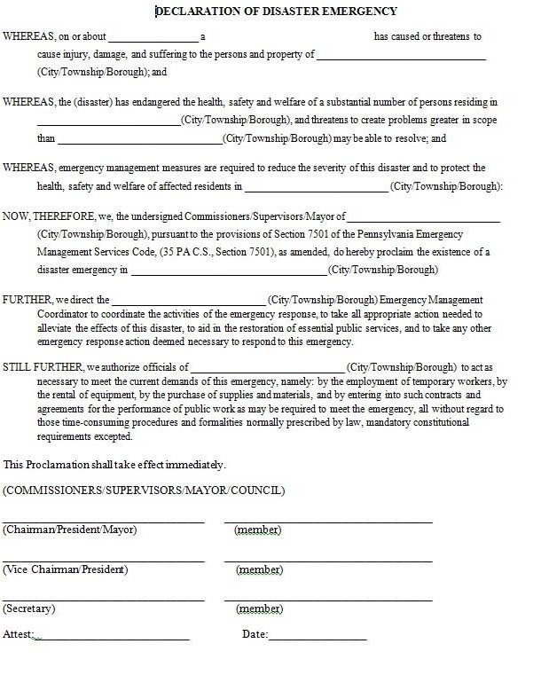

### Submitting a Local Situation Report

In the event of a major disaster or emergency in the County, emergency responders at the local level of government will initially assess the situation and identify the need for response operations.

However, there are instances when an emergency or a disaster situation is greater than the response capabilities of local government. In the event of such an emergency, the Jefferson County Emergency Management Agency is the county agency that local governments may contact to begin the process of effectively securing resources.

To begin this process, local government must accurately prepare and submit a Local Situation Report (ICS 209) in a timely manner. The Situation Reports from local governments will be used by the EOC to determine the scope of the problem and to begin the process of obtaining supplemental state and federal disaster assistance.

Initial Reports are to be submitted to the EOC within 24 hours after the start of the emergency and afterwards daily reports are submitted until a final report is submitted to the EOC. You can fax or email the report to the EOC via [des@jeffersoncountypa.com](mailto:des@jeffersoncountypa.com).

If the previous pathways are not a viable option, you may call the EOC and have your report taken over the telephone. When calling it in, have your report prepared and refer to the report sections when you talk to the report taker.

When resources are requested, be as specific as possible. Request items by their type e.g. wheel loader backhoe as opposed to heavy equipment. For ease of ordering and tracking, response assets need to be categorized via resource typing. Resource typing is the categorization and description of resources that are commonly exchanged in disasters via mutual aid, by capacity and/or capability. Through resource typing, disciplines examine resources and identify the capabilities of a resource’s components (i.e., personnel, equipment, and training). During a disaster, an emergency manager knows what capability a resource needs to have to respond efficiently and effectively. Resource typing definitions will help define resource capabilities for ease of ordering and mobilization during a disaster. As a result of the resource typing process, a resource’s capability is readily defined and an emergency manager is able to effectively and efficiently request and receive resources through mutual aid during times of disaster.

A copy of the ICS form follows.

16-10

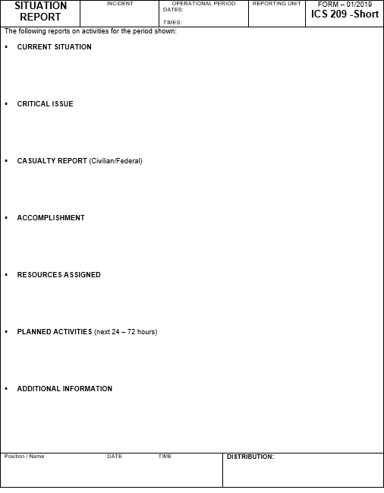

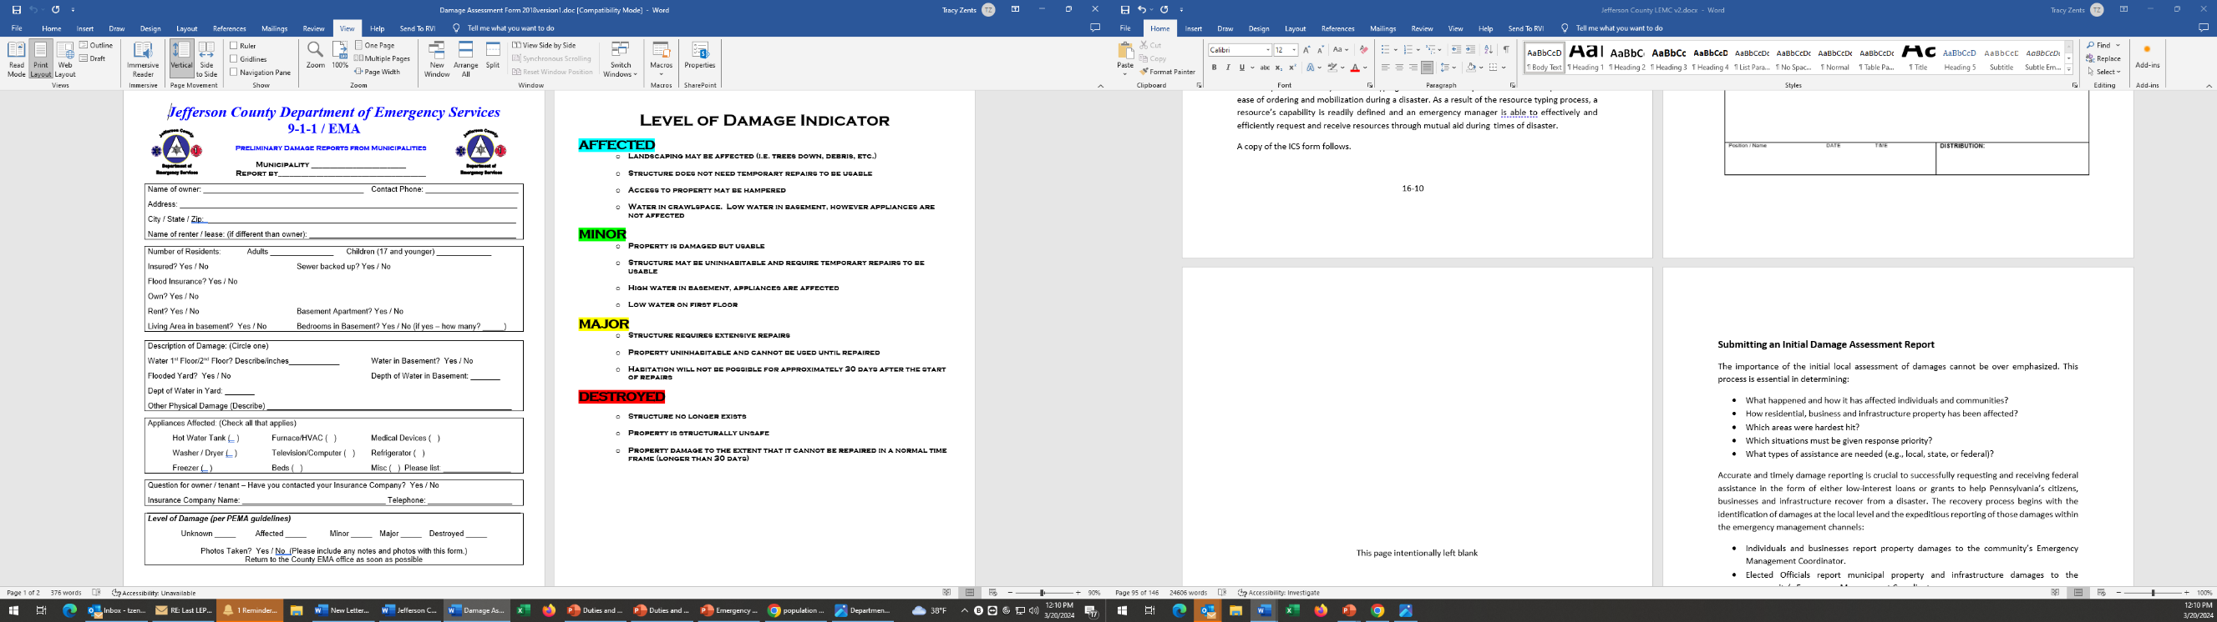

### Submitting an Initial Damage Assessment Report

The importance of the initial local assessment of damages cannot be over emphasized. This process is essential in determining:

* What happened and how it has affected individuals and communities?
* How residential, business and infrastructure property has been affected?
* Which areas were hardest hit?
* Which situations must be given response priority?
* What types of assistance are needed (e.g., local, state, or federal)?

Accurate and timely damage reporting is crucial to successfully requesting and receiving federal assistance in the form of either low-interest loans or grants to help Pennsylvania’s citizens, businesses and infrastructure recover from a disaster. The recovery process begins with the identification of damages at the local level and the expeditious reporting of those damages within the emergency management channels:

* Individuals and businesses report property damages to the community’s Emergency Management Coordinator.
* Elected Officials report municipal property and infrastructure damages to the community’s Emergency Management Coordinator.
* Community Emergency Management Coordinators report damages to residential, business and municipal property and infrastructure within their community to the County Emergency Management Coordinator.
* County Emergency Management Coordinators report overall damages to residential, business and municipal property and infrastructure within their county to PEMA using the Initial Damage Reporter function of the automated Pennsylvania Emergency Information Reporting System (PEIRS).

PEMA analyzes the damage information it receives from the county(s) to determine if the event warrants requesting assistance from either FEMA or the SBA.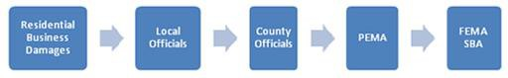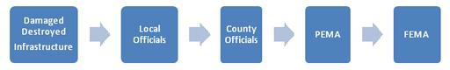

# Recovery Toolkit

# 17-1

### Recovery Checklist

❏ Review responsibilities and authorities with legal counsel and ensure existing laws/ordinances provide the capability to implement the necessary actions to ensure the health, safety and welfare of citizens while addressing critical issues in support of recovery process (e.g., protective measures, access restrictions, reentry policies, curfews, price controls, public nuisance and other emergency rules of operation etc.).

❏ Review and brief department staff on disaster assistance available under the Stafford Act, SBA and other applicable disaster assistance programs, and explain associated program requirements relating to cost reimbursement, documentation and procurement.

❏ Review existing financial system policies, procedures and supporting infrastructure to ensure framework is structured to effectively capture and track disaster costs being generated by all departments as soon as response and recovery activities are initiated (e.g., personnel, equipment, supplies, contract services, travel etc.), and facilitates the sorting, retrieving and packaging of this information and associated documentation for cost reimbursement purposes.

❏ Request all departments review staffing requirements and develop plan to fulfill anticipated needs (e.g., other departments, Mutual aid, statewide mutual aid, volunteers, local hires, contract services).

❏ Develop/provide the necessary pre-event as well as Just-In-Time training to ensure the effective and timely implementation of disaster recovery plans.

❏ Review/revise overtime and compensatory time policies to support recovery operations

❏ Develop pre-scripted announcements to support recovery process

❏ Review current resource inventories and contracts in place in context of anticipated department needs, and develop resource management plan that defines strategy to fulfill disaster recovery resource needs (e.g., establish additional contracts; mutual aid; Statewide Mutual Aid; donations etc.)

❏ Develop plan to effectively manage and distribute donations during recovery period.

❏ Identify staff to support local damage assessment teams and provide the appropriate training to prepare teams to accomplish task in an effective and timely manner.

17-3

❏ Develop the necessary forms, procedures, and plans to support damage assessment process, and identify the necessary resources teams will need to perform work.

❏ Prepare debris management plans for community to ensure timely debris clearance of key roads, access to critical facilities/infrastructure pre-identified during planning process, and the elimination of debris-related threats to public health and safety

❏ Pre-establish local debris contracts to enhance capabilities to execute plans and address debris removal needs in a timely and effective manner.

❏ Include representation from critical facilities/infrastructure, utilities, voluntary organizations and appropriate private sector partners etc. in planning process to ensure effective communications, coordination and interface during recovery operations.

❏ Develop capability to effectively monitor all contract services employed to support response and recovery operations utilizing internal and external resources (e.g., monitoring contract, mutual aid etc.).

❏ Develop access/re-entry plan to area impacted by disaster that addresses health and safety issues as well as resident and business needs.

❏ Develop plan to facilitate permit/code compliance during recovery period

❏ Continually assess needs, monitor progress and develop plan to transition back to normal operations at the appropriate time.

❏ Conduct an After-Action Review (AAR) of Response and Recovery Operations and develop plan to enhance operations and address shortfalls.

17-4

### Stafford Act Declaration Process

Local jurisdictions impacted by a disaster may declare a local emergency pursuant to the authority provided to them Title 35 Health and Safety Part V. Emergency Management Services. The declaration allows the locality to request and receive the necessary assistance and support from the state, the federal government and other local government agencies in partnership with private and non-profit organizations, in an expeditious, effective and timely manner.

Once the life-safety issues are addressed, one of the most critical tasks of the community is to effectively develop and submit the necessary information that accurately characterizes the severity and magnitude of a disaster’s impact on the community in a timely manner.

This information is vital in assisting all levels of government in determining the best course of action for obtaining and providing assistance to disaster victims either under the Stafford Act or from other sources such as the SBA, state agencies and non-governmental private/non-profit organizations etc.

This determination is accomplished through the damage assessment process which is comprised of two components:

* The Initial Damage Report which is performed by the jurisdiction; and
* The Preliminary Damage Assessment which is performed by a team of federal, state and local officials.

#### Initial Damage Reporting (IDR)

The damage assessment process must be looked at as a continuum with the initial damage report providing the first description of the type and scope of damages and associated impacts sustained by the community from the event. When this information is submitted to the Jefferson County EOC it is forwarded to PEMA for evaluation.

Consider using what’s called a Windshield Assessment. A windshield survey is a quick visual overview of the affected area performed within the first 24 hours after the disaster. The purpose of the survey is to

* determine what happened,
* determine where it happened, and
* determine the extent of the damages by viewing as much of the affected area as possible.
* affected, minor, major, destroyed

17-5

Additional information might be requested as necessary to ensure the information submitted adequately captures what happened, the impact to the communities involved, unmet needs and the areas hardest hit. This information will assist in identifying the types of resources/assistance needed as well as community priorities.

It is critical that the information provided in the IDR accurately reflects the damages and impacts sustained by the community, as the decision to request a Preliminary Damage Assessment and seek a presidential disaster declaration is made on the basis of this information.

#### Preliminary Damage Assessment (PDA)

If the information received supports seeking a Presidential declaration, the Commonwealth will make a request to FEMA Region III to conduct a Preliminary Damage Assessment (PDA) in coordination with the state and localities impacted, to verify the damages and estimate the amount of supplemental assistance that will be needed. If FEMA concurs with the state’s assessment, teams of inspectors for the potential applicable federal disaster assistance programs available under the Robert T. Stafford Act as amended (e.g., Individual Assistance, Public Assistance and Hazard Mitigation) will be deployed to the state.

The county and municipality is responsible for providing a representative to take the state and federal representatives to the damaged sites. The municipality should have sites identified and illustrated on maps to facilitate the process.

Information in regard to applicable insurance in force, cost estimates, site photographs, budget and other supporting documentation should be gathered or developed, to the extent possible between the time of the IDA and the PDA, and made available to the teams to assist them in their assessment process. The tour itinerary should be established prior to the teams arriving beginning with the worst sites first.

Once the PDA is completed, the FEMA PDA team representative will submit a report to FEMA Region III with their findings.

IDAs are always performed by a locality after a disaster event because it is the process by which the locality determines the extent of damages to the community. PDAs are only performed when the evaluation of IDAs by EMA indicates that damages are significant enough that it is likely federal assistance will be approved, if requested.

Not all disaster events will result in the request for or approval of federal assistance under the Stafford Act.

17-6

#### Declaration Request

If the PDA verifies that there may be sufficient damage to the affected communities to warrant a presidential declaration, the Governor will send a letter to the President through the FEMA Region III Regional Director (RD) requesting an emergency or major disaster declaration. The letter will include, but not be limited to, the following: a description of the disaster event that generated the request; the characteristics of the area; the impact on the affected communities; the protective measures employed; the resources committed; the economic impact precipitated by the event; as well as the preliminary damage assessment results. The RD will review the request and prepare a summary report with a recommendation to the Director of FEMA/FEMA Headquarters, who in turn makes a recommendation to the President.

If the Governor’s federal declaration request is approved, the declaration will specify the federal assistance programs that will be made available to the state, as well as the jurisdictions included in the action. After the initial declaration, the individual designated by the Governor as the Governor’s Authorized Representative (GAR) may request additional jurisdictions to be eligible for assistance or for additional types of assistance as deemed necessary. In certain circumstances, when the magnitude of the disaster event warrants, the President may expedite the declaration process.

If the federal declaration request is denied, the Governor may file an appeal to the President through the FEMA Regional Director in accordance with federal requirements, within thirty days of the date of the letter denying the request. The appeal must include any new information developed following the initial request to support and justify reconsideration of the denial.

#### Public Assistance Process

Public Assistance is a grant program funded by FEMA that assists state and local government and certain private non-profit (PNP) entities with the response to and recovery from disasters.

Once a disaster occurs, each locality should do an initial damage assessment. This information will help the state determine if there is enough damage to begin the public assistance process. Below the steps of the process are outlined.

#### Preliminary Damage Assessment

The Preliminary Damage Assessment (PDA) is a joint assessment used to determine the magnitude and impact of an event's damage. A FEMA/state team will usually visit local applicants and view their damage firsthand to assess the scope of damage and estimate repair costs. The state uses the results of the PDA to determine if the situation is beyond the combined capabilities of the state and local resources and to verify the need for supplemental federal assistance. The PDA also identifies any unmet needs that may require immediate attention.

17-7

#### Presidential Disaster Declaration

Once a disaster has occurred, and the state has declared a state of emergency, the state will evaluate the recovery capabilities of the state and local governments. If it is determined that the damage is beyond their recovery capability, the Governor will normally send a request letter to the President, directed through the Regional Director of the appropriate FEMA region. The President then makes the decision whether or not to declare a major disaster or emergency.

After a presidential declaration has been made, FEMA will designate the area eligible for assistance and announce the types of assistance available. FEMA provides supplemental assistance for state and local government recovery expenses, and the federal share will always be at least 75 percent of the eligible costs.

#### Applicants’ Briefing by Grantee

The Applicants’ Briefing is a meeting conducted by the State to inform prospective applicants of available assistance and eligibility requirements for obtaining Federal assistance under the declared event. The meeting is held as soon as practicable following the President's declaration.

* During the briefing, the State will present the incident period and a description of the declared event.
* The State will also discuss funding options, record keeping and documentation requirements, and Special Considerations issues.
* Applicant, work, and cost eligibility will be reviewed and the project formulation process will be introduced.
* Typically, applicants will prepare and submit their Requests for Public Assistance form during the briefing.

#### Submission of Request for Public Assistance by Applicant

The Request for Public Assistance is FEMA’s official application form that public and private nonprofit organizations use to apply for disaster assistance. It is a simple, short form with self- contained instructions. “The Request” (FEMA form 90-49) asks for general information which identifies the applicant, starts the grant process and opens the Case Management File, which contains general claim information as well as records of meetings, conversations, phone messages and any special issues or concerns that may affect funding.

17-8

The Request must be submitted to the State Public Assistance Officer within 30 days of the date of designation of an area. The form may be delivered in person at the Applicants' Briefing, sent by mail, faxed.

#### Kick-off Meeting with Public Assistance Coordinator (PAC)

The first meeting between the applicant, the Public Assistance Coordinator (PAC) and Applicant Liaison is called the Kick-off Meeting. A Kick-off Meeting is held with each applicant to assess the applicant’s individual needs, discuss disaster related damage, and set forth a plan of action for repair of the applicant’s facilities. The Liaison will provide State specific details on documentation and reporting requirements. Both the PAC and Liaison help in identifying Special Considerations.

October

#### Project Formulation and Cost Estimating

Project formulation is the process of documenting the damage to the facility, identifying the eligible scope of work and estimating the costs associated with that scope of work for each of the applicant's projects.

Project formulation allows applicants to administratively consolidate multiple work items into single projects in order to expedite approval and funding, and to facilitate project management. A project is a logical method of performing work required as a result of the declared event. More than one damage site may be included in a project.

#### Project Review and Validation

The purpose of validation is to confirm the eligibility, compliance, accuracy, and reasonableness of small projects formulated by an applicant, and to ensure that the applicant receives the maximum amount of assistance available under the law.

The process reviews approximately 20% of the small projects formulated by the applicant. This 20% sampling applies to all small projects, including emergency work, permanent work, and small projects with Special Considerations. All aspects of the projects are reviewed including the sites, estimating methods, and documentation related to the project.

The process of approval, as outlined above, begins with the PAC’s review of PWs for completeness. Once the PWs are reviewed and processed through validation and Special Considerations review as appropriate, the PWs are ready for approval and funding.

17-9

The PAC has the authority to approve projects up to $100,000. Therefore, any project below this threshold will be approved by the PAC and forwarded for funding. Projects over this threshold will be forwarded by the PAC to the PAO with a recommendation for approval. Once the PAO has approved the PW, it will then be forwarded for funding.

#### Obligation of Federal Funds and Disbursement to Subgrantees

FEMA and the grantee share responsibility for making Public Assistance Program funds available to the subgrantees. FEMA is responsible for approving projects and making the Federal share of the approved amount available to the grantee through a process called obligation.

Through obligation FEMA notifies the grantee that the federal funds are available but reside in a Federal account until the grantee is ready to award grants to the appropriate subgrantees. The grantee is responsible for providing the grantee portion of the non-federal share of the grant amount and for notifying the subgrantee that funds are available.

Payment for small projects is made on the basis of the estimate prepared at the time of project approval. The grantee is required to make payment of the Federal share to the subgrantee as soon as practicable after FEMA has obligated the funds.

Large projects are funded on documented actual costs. Because of the nature of most large projects, work typically is not complete at the time of project approval; therefore, FEMA will obligate grants based on an estimated cost. Such monies may not be immediately drawn down by the State. Instead, progress payments are made to the applicant as actual costs are documented.

Upon completion of a large project, an applicant must submit documentation to account for all incurred costs to the grantee. The grantee is responsible for ensuring that all incurred costs are associated with the approved scope of work and for certifying that work has been completed in accordance with FEMA standards and policies. The grantee then submits documentation of project costs to FEMA for review. FEMA may conduct a final inspection as part of this review. Once the review is complete, FEMA determines whether funds should be obligated or deobligated for the project.

#### Appeals and Closeout

The appeals process is the opportunity for applicants to request reconsideration of decisions regarding the provision of assistance. There are two levels of appeal:

* The first level appeal is to the Regional Director.
* The second level appeal is to the Assistant Director at FEMA Headquarters.

17-10

The applicant must file an appeal with the Grantee within 60 days of receipt of a notice of the action that is being appealed. The applicant must provide documentation to support the appeal. This documentation should explain why the applicant believes the original determination is wrong and the amount of adjustment being requested.

The purpose of closeout is to certify that all recovery work has been completed, appeals have been resolved and all eligible costs have been reimbursed. Closeout is an important last step in the Public Assistance Program process.

#### Categories of Work

To facilitate the processing of Public Assistance Program grants, FEMA has divided disaster related work into seven, Categories of Work. These categories are listed below.

#### Emergency Work

Category A: Debris Removal

Clearance of trees and woody debris; building wreckage; sand, mud, silt, and gravel; vehicles; and other disaster-related material deposited on public and, in very limited cases, private property.

Category B: Emergency Protective Measures

Measures taken before, during, and after a disaster to save lives, protect public health and safety, and protect improved public and private property.

#### Permanent Work

Category C: Roads and Bridges

Repair of roads, bridges, and associated features, such as shoulders, ditches, culverts, lighting and signs.

Category D: Water Control Facilities

Repair of irrigation systems, drainage channels, and pumping facilities. Repair of levees, dams, and flood control channels fall under Category D, but the eligibility of these facilities is restricted.

17-11

Category E: Buildings and Equipment

Repair or replacement of buildings, including their contents and systems; heavy equipment; and vehicles.

Category F: Utilities

Repair of water treatment and delivery systems; power generation facilities and distribution lines; and sewage collection and treatment facilities.

Category G: Parks, Recreational Facilities, and Other Items

Repair and restoration of parks, playgrounds, pools, cemeteries, and beaches. This category also is used for any work or facility that cannot be characterized adequately by Categories A-F.

17-12

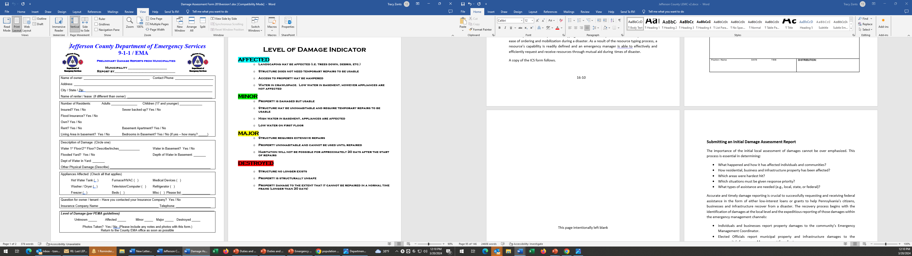

### Detailed Information

**Name of Event:** Name the event based on type, “Flash Flooding”, “Winter Storm”, “Commercial Fire”, whatever initiated the causation of the report.

**Date:** This should be the date that the event occurred. May not be the date that you submitted the report. However, EMA hopes that you will be able to submit your IDR within 12-hours of the event occurring.

**County & Municipality:** Self-explanatory, however, if the Local EMS is responsible for several municipalities, they must separate the reports by each.

**Time of Report:** This should reflect the time the report was prepared, regardless of the time that the event occurred.

**Disaster Declared – Yes/No, Date & Time:** Please indicate if the municipal officials have formally issued a Disaster Declaration related to this IDR. Include the date and time that the declaration was made. Also, make sure a copy of the Disaster Declaration is forwarded to the County EMA office.

**Causalities:** If known, list the total numbers, within the municipality, of individuals who are injured or deceased, related to this event. This should include those people who are missing or unaccounted for at the time of the report.

**Damages:** Breakdown the damages to private homes, businesses, and public buildings into the destroyed, major, minor, and affected groups, with totals for each type. Follow the guidance below for assessing damage definitions.

**Total numbers, Hospitalized; Evacuated; Sheltered:** These totals should be at the time of the report. They do not need to be exact, an estimate at the time of the report is sufficient.

**Free Text Field, Roads; Bridges; Water & Sewerage Treatment:** Damage to Public property needs to be specifically addressed. Flooded roadways that are not damaged but impassable at the time of the report can also be identified. These should be indicated with a definable location so they can be mapped for post disaster inspection. Treatment facilities that are affected are big ticket losses that can impact the overall State and Federal Damage Assessments in the days following. Always include pictures and GPS coordinates of damages.

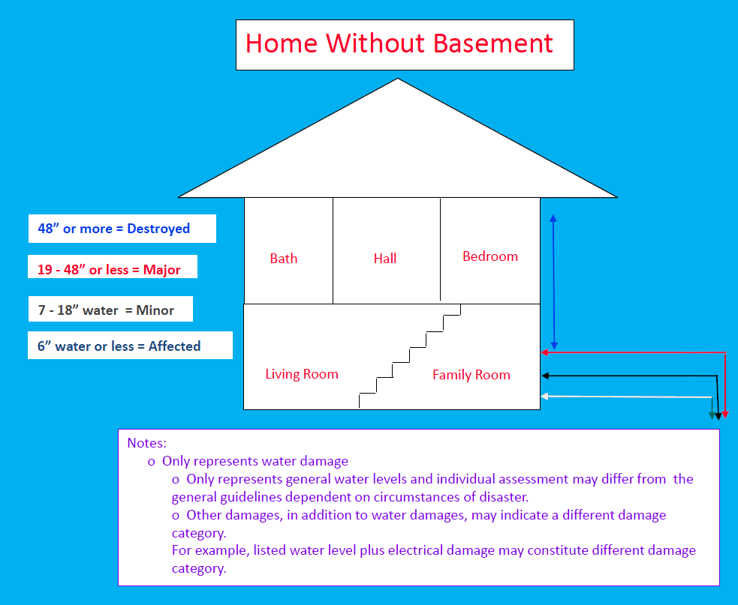

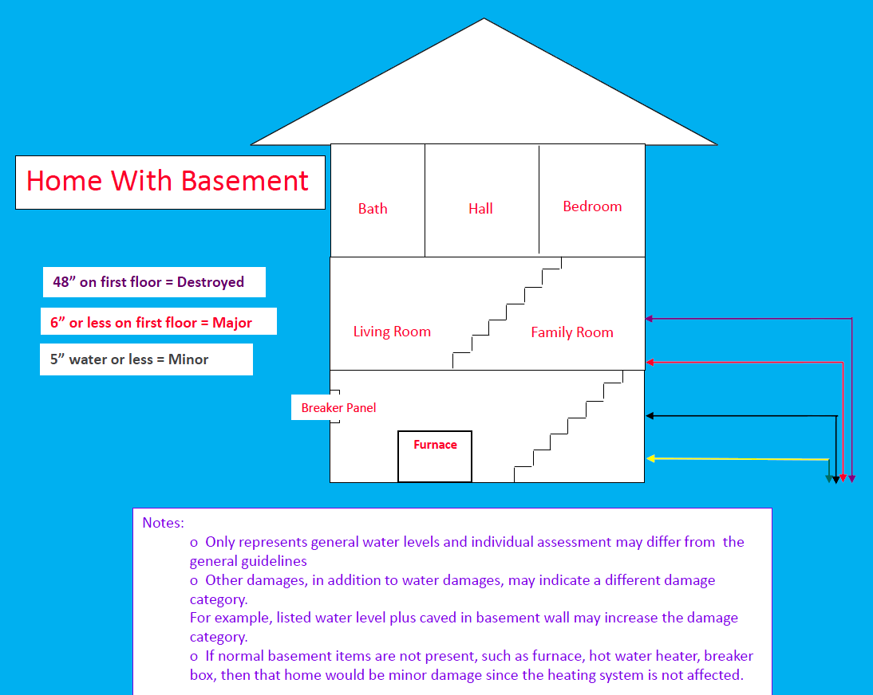

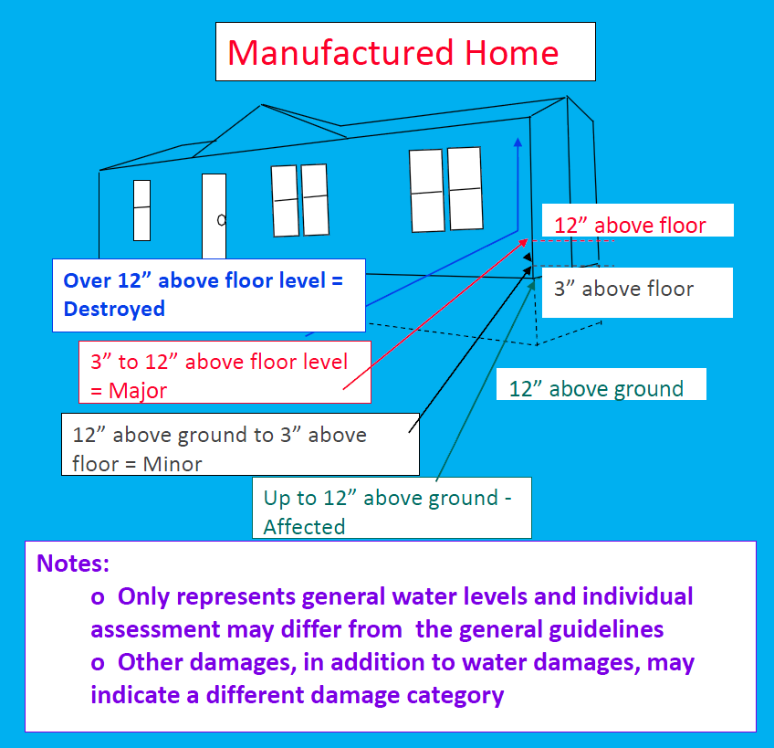

# Mitigation Toolkit

18-1

### Hazard Mitigation

Hazard mitigation has been called the cornerstone of emergency management. It is defined as any sustained actions that reduces or eliminates injury to people, damages to property and supports continuity of critical societal operations during natural or human-caused disasters.

Mitigation involves keeping homes away from floodplains, flood proofing flood-prone structures, installing shutters in hurricane and wind zones, and creating and enforcing effective zoning ordinances and building codes. It also includes elevating homes and items within the homes to keep them dry in case of flooding.

The Commonwealth’s hazard mitigation program is directed through PEMA. PEMA has created a number of tools to assist counties with hazard mitigation planning. Pennsylvania's All-Hazard Mitigation Planning and Project Identification Toolkit (HM Toolkit) is a culmination of all "tools" created to standardize, streamline and simplify the hazard mitigation planning process in the Commonwealth. "Tools" within the HM Toolkit include:

* Pennsylvania's All-Hazard Mitigation Planning Standard Operating Guide (SOG)
* Pennsylvania's All-Hazard Mitigation Tool (PA Tool)

# Media Toolkit

19-1

### Media Checklist

❏ Reach out for assistance in your community for PIO assistance.

❏ Write news releases and hold news conferences as needed.

❏ Develop talking points for call centers, interviews and news conferences.

❏ Coordinate publicly released information within your organization and with your partners.

❏ Share publicly released information with the county PIO.

❏ Videotape and photograph on-scene damage as needed.

❏ Monitor the TV news and Internet for rumors, trends and inaccuracies.

### PIO Assistance

Every emergency manager should become familiar with the resources in their own communities.

Send personnel to a Basic PIO class such as IS-29 -Public Information Officer Awareness Training, reach out to partner organizations and regional counterparts to learn how they can help you with public information during a crisis.

Jefferson County’s PIO might be able to help in certain situations, depending on availability.

### News Releases

A news release is one way to get information to the public. News releases are written in the form of a newspaper article, using the inverted pyramid style (most important information first).

Whether during routine or disaster operations, a news release is a proactive way to establish a relationship with members of the media, and it can get the message to the widest audience, generate follow-up coverage and establish your credibility as a source of information.

#### Writing Tips

* Use simple words. Say “best use,” not “optimum utilization.”
* Use words that best describe exactly what you want to say. These often are concrete rather than abstract words. If you are writing about a fire truck, call it a fire truck, not an emergency response vehicle.
* If you must use a technical term, explain it.
* Write in a conversational style.
* Use short sentences.
* Start with your conclusion or a summary that tells the whole story. Tell the reader up front who, what, when, where, why and how, and then spend the rest of the writing expanding on those facts.
* When you come to the end, stop. There is no need for a conclusion at the end.
* Write in the active voice. Say, ‘The hurricane caused more than a million dollars in damage,” not “More than a million dollars in damage was caused by the hurricane.”
* Avoid imprecise words like “substantial” or “significant.”
* Use expressive, meaningful verbs. Say, “Tax revenues decreased 10 percent” rather than “Tax revenues were negatively impacted.”

19-4

### Talking Points

Talking points are a reference sheet that outlines the main messages a speaker wants to cover, usually formatted as a bulleted list of one or two lines per point. They are helpful guidelines for news conferences, call centers and interviews.

### Coordinating and Sharing Information

It is extremely important during particularly newsworthy incidents to keep the county PIO apprised of the public information you are giving to your local media and the community.

This coordination is helpful to prevent conflicting messages and to inform the PIO about your situation. Sharing your news releases with the PIO is in no way intended to be an approval process, simply information sharing.

If the county EOC is activated, the PIO will share their news releases with local governments as well.

19-5

### Emergency Public Information Checklist

**Instructions:** This checklist includes planning considerations for the emergency public information function.

|  |
| --- |
| **EMERGENCY PUBLIC INFORMATION CHECKLIST** |
| **Purpose:** To describe the means, organization, and process by which local government will provide timely, accurate, and useful information and instructions to area residents throughout an emergency. |
| **Situation and Assumptions** |
| * Which emergencies require activation of the emergency public information response organization * Means of dissemination available. * Principal means of dissemination (warning systems; TV; radio; cable; newspapers; specially printed material). * Coverage by each means (broadcast area, readership, etc.). * Vulnerability of dissemination systems. * Dependency on outside media. * Audience characteristics:   Special-needs groups.  Preparedness (ongoing preparedness efforts).   * Assumptions about the media. Examples of these assumptions are:   Local media will cooperate on placing emergency public information ahead of regular news coverage.  External media interest will create heavy demands on the emergency public information organization.   * Assumptions about the audience. An example of these assumptions is that people will want more information and will call to get it, if possible. |

|  |
| --- |
| **EMERGENCY PUBLIC INFORMATION CHECKLIST** |
| **Concept of Operations** |
| * Who activates the emergency public information function? * How the emergency public information function is notified. * Where emergency public information personnel should report. * Priorities for emergency public information activity (e.g., production and dissemination of emergency public information, response to public inquiry, monitoring and rumor control, media relations). * Emergency public information general policies (e.g., single emergency public information release point, focus on specific types of information, provision of reassuring information when possible). * Actions and message content for phased activity (increased readiness, limited warning available, post-impact). * How emergency public information will be coordinated internally (coordination among Administrators, Public Information Officers (PIO), and other government entities). * Procedures for verifying and authenticating information and for obtaining approval to release information. * How the community will deal with media convergence. * Provisions for coordination (local-local, local-National). |
| **Organization and Assignment of Responsibility** |
| * Emergency public information function in chart form. * Specific emergency public information responsibilities that are assigned to ministries, organization chiefs, and individuals. |
| **Administration and Logistics** |
| * General support requirements for the emergency public information function. * Reporting and information flow for emergency public information. |

|  |
| --- |
| * How core emergency public information staff will be augmented, when necessary. * Facilities to be used for emergency public information, and how additional facilities will be obtained, if necessary. * Reference to standard operating procedures for setting up emergency public information facilities. * Special equipment needs for emergency public information, and how they will be met. * Agreements with suppliers (e.g., printers), including contact points. |

19-8

**MEDIA INTERVIEW TIPS**

|  |
| --- |
| A media interview is a communication opportunity. No matter what topic the  interviewer has in mind, you have the opportunity to make your own key points. Here are a number of tips to help you stay in control of the interview process.  *Before*   * Track all media inquiries and note the reporter’s name, organization, date and purpose. * If possible, review the scope of the interview with the reporter so you may anticipate what might be asked. * Provide background information that helps the reporter understand the issues. * Identify the points that you want to communicate during the interview and make sure these facts come to mind easily. * Identify a message that you can incorporate into your first and last remark (e.g., Reporter opens interview saying “Thanks for talking with us today.” You answer: “I’m proud to speak on behalf of this unified response effort,” or “Thank you for this chance to promote flood insurance.”) * Dress appropriately. |
| *During*   * Listen to the entire question before answering. * Avoid speculation. * Beware of false assumptions and erroneous conclusions. * Avoid hypothetical questions. * Be alert to multiple questions, and address them individually. * Be confident and concentrate on delivering your message. * Keep your answers simple and direct. * Speak in “sound bites” (concise, memorable explanations).   19-9 |

|  |
| --- |
| * Never repeat inaccurate or damaging information spoken within a reporter’s question. Instead, state the information in a positive manner within your answer. * Do not refer to the reporter by name during your answers, as the reporter may not be included when the interview is aired. * Treat all questions seriously. * NEVER speak “off the record.” * While answering questions, be attuned to opportunities to promote *your* messages. * When you have answered well, stop speaking. Resist the urge to “fill the silences.” * If you are being recorded or taped and botch an answer, simply begin the answer again. If taped, the exchange will most likely be edited. * Avoid nervous gestures. * Display good posture and maintain eye contact. * If you wear glasses, ensure they are not slipping downward. Remove dark glasses. * Avoid wearing stripes and red * Do not overuse hand gestures. * If seated, ensure that your jacket does not ride-up by sitting on the coattails. * Leave all equipment concerns to reporter or sound technician. |
| *After*   * Obtain any information you promised to supply. * Provide written background information, and be available to the reporter for follow- up questions. * If the story is publicized with inaccuracies, call the reporter and politely point out the errors.   19-10 |