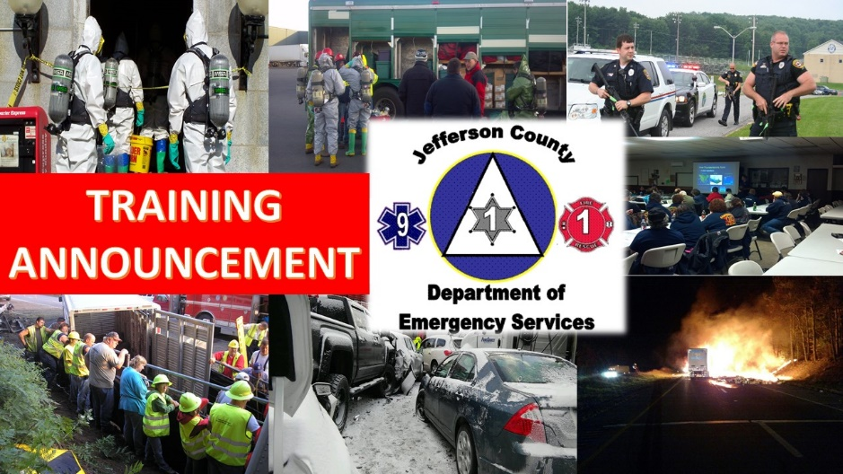  SAturday: November 2nd, 2024  and  Sunday: November 3rd, 2024  Time: 8am to 4pm- Both days  Trench Rescue  The Pine Creek Volunteer Fire Department in cooperation with the Jefferson County Department of Emergency Services will be hosting a Trench Rescue course, to be held at the Pine Creek Volunteer Fire Department.  This course will introduce personnel to the knowledges and skills necessary to safely and effectively perform complex rescue operations in collapsed trench excavations. Course work will include practical drills and demonstration in simulated trench excavations.  Personnel will need: long pants/rescue overalls, long shirt, hard hat and boots  Prerequisites for this course include: ELIS    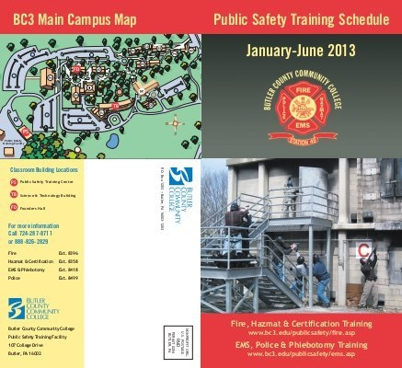  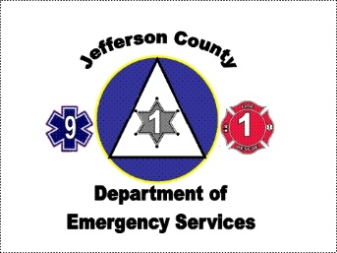 | To register, contact  Ashley Allshouse  aallshouse@jeffersoncountypa.gov  814-849-1582  Or  Scan QR code below to register  Deadline to Register  October 18th, 2024  Lead Instructor  Greg Dinko  to be held at:  Pine creek Fire department  18656 Route 322  Brookville, PA 15825  

